Muse Agent Traffic Study
Oct 21, 2026 · @Jim

Executive summary
The answer. Muse-driven sessions can be attributed on the portal with measured confidence, but not by any product as shipped. Muse presents as stock desktop Chrome on Linux, arrives from Cloudflare and Fastly address space (or from the customer's own line when the Mac app drives it), signs nothing and reports no automation flags. F5 and Akamai collect the right signals and ship the enforcement plumbing; neither names Muse. Attribution therefore has to be built as a session-scoring layer the team owns, fed by the vendor sensor, a first-party interaction beacon on the five flows and the account's own device history, and calibrated in a lab against the cohorts a wrong rule would hurt most: iCloud Private Relay, WARP and VPN users, screen-reader users and enterprise proxies.
Why it is detectable. Four signal families survive Muse's hardening: an honest Linux cloud-VM environment with a software renderer, which is hard to fake without lying about the OS; egress from shared CDN pools, used only as a prior once Apple's Private Relay list is subtracted; accessibility-tree input artifacts that screen readers do not produce, such as a single teleported mouse move before an exact-center click and input without key events; and fleet behavior, near-identical fingerprints across many accounts that change browser version in lockstep. The open question that matters most is whether Muse's input shows those artifacts at all, since one tester saw real key cadence; Experiment 4 settles it by week 5, and the design falls back to environment, egress and fleet signals if it does not.
What is solved and what is not. Solved on paper: the three tiers (T0 undeclared automation, T1 cloud-browser agent, T2 Muse-attributed), a five-rung response ladder built on F5 and Akamai primitives, a lab that bounds the false-positive rate per cohort, and the channel design. Not solved anywhere, and not claimable until the lab runs: Muse's precision and recall on this portal, whether Muse relays an "automation not authorized" notice to its user, and which step-up variants it cannot complete alone. The vendors that name Muse today (DataDome, HUMAN, Arkose, Fingerprint, Cequence) do so on undisclosed rules measured on their own networks.
Recommended posture. The bank hybrid, sequenced: observe in shadow for a full weekly cycle; step up every sensitive write with a push or passkey to the customer's own device; open a scoped, read-first MCP channel and submit it to Meta; block credential-driven writes last, narrowly and with an explanation. This keeps control of cancellations, plan changes and credits, keeps the customer who sent the agent, and survives Muse adopting a signing standard. A pure block is the only stance with a public standoff on record (Amazon), a channel alone does nothing about the browser path, and observe-only is where every US carrier sits today by default.
Decisions for the sponsor, with the defaults the program starts on unless changed:
- False-positive budget: 0.5% per sensitive cohort, bounded on 600 sessions each. A tighter budget needs 1,000 or more sessions per cohort and adds about two weeks.
- Enforcement holdout: a permanent 5% of sessions never enforced, the control group for cancellation and credit outcomes.
- Stance sequence: observe, step-up, channel, block last; the browser-write-path decision is held until a listed connector exists (gate 3, about week 16).
- Meta submission: submit the read-only connector to platform.muse.ai in week 6, accepting that the review's length is Meta's to set.
- Lab conduct: five Muse accounts on consenting employees, a synthetic replica holding no customer data, throwaway credentials, opt-out of Meta training where the app allows, no probing of Meta's defenses.
- The block rung, the one choice that is hard to reverse in public: recommended as last, narrow and explained.
Exposure, sized from the portal's own numbers. The study found no public carrier figures, so two formulas replace a guess:
- Revenue at risk per month = cancel and retention-desk sessions per month × share at T1 or T2 (measured in shadow mode) × average concession or lost inertia revenue per agent-completed cancel. Public reports put negotiated concessions at $5 to $30 a month per success, and the Stanford estimate is that cancellation friction roughly doubles subscription revenue.
- False-positive cost per month = sessions on the five flows per month × sensitive-cohort share (Private Relay, VPN, assistive technology; typically low single digits) × false-positive rate (budget 0.5%) × cost per contact or lost customer.
Both come out of the first 30 days of shadow mode; neither can be estimated credibly before it.
Cost of the detection side (estimates; no public comparable exists). A team of six to eight for the first two quarters: two bot-management or edge engineers for F5 or Akamai policy, EdgeWorkers and iRules; two data or ML engineers for the scoring service and the lab pipeline; one security analyst for daily session review; one product or accessibility lead for the step-up and interstitial; part-time contact-center and policy liaison. Licensing: dedicated F5 XC Bot Defense and Akamai Bot Manager test instances for the lab (trial or existing entitlement), Akamai Bot Manager Premier if behavioral biometrics are wanted on the five flows, and a browser-side signal provider (Fingerprint or Arkose) as a contingency bought only if the lab shows the incumbent stack missing budget. Infrastructure is not the driver. The MCP channel is costed separately in the case study: platform, identity, security and product squads of 15 to 24 people.
Day-30 checkpoint. By the end of week 4 the sponsor should see the replica live behind both vendor stacks; the first 500 Muse runs captured, with a fleet signature and first readings from Experiment 1 (does Muse relay the notice) and Experiment 4 (does its input carry automation artifacts); the read-only pilot answering catalog queries; and a first measured false-positive rate on the Private Relay and screen-reader cohorts. If any of these is missing, the week-6 gate moves.

Problem statement, scope and success criteria
The study has to deliver two things: a way to attribute Muse-driven sessions on the customer portal with measured precision, and a response design that runs on standard edge products (F5 and Akamai first) across five account flows.
The problem. Meta's Muse agent drives a full browser inside a per-user cloud VM through authenticated customer sessions to manage accounts and negotiate bills. It does not declare itself, so the site cannot tell a Muse session from a customer in Chrome. The usage policy prohibits automation, but today there is no reliable way to see it, let alone act on it.
In scope
- Flows: billing, plan change, cancel, chat, account change. Web channel only.
- Attribution in three tiers, each with precision and recall measured on labeled ground truth:
  - T0 — undeclared automation of any kind
  - T1 — cloud-browser agent (Muse, ChatGPT's cloud browser, Grok Bot, OpenClaw-class)
  - T2 — Muse-attributed
- A false-positive budget set per cohort: iCloud Private Relay, VPN and Cloudflare WARP, assistive technology, enterprise proxies. Proposed default: 0.5% per sensitive cohort, bounded on 600 sessions each; the sponsor confirms or changes it before the lab starts.
- Tooling: achievable with existing products — F5 (BIG-IP Advanced WAF, Distributed Cloud Bot Defense) and Akamai (App & API Protector, Bot & Abuse Protection, Account Protector) first, with Cloudflare, DataDome, HUMAN, Imperva, Kasada and AWS WAF as alternatives.
- Policy options analyzed with upside and downside of each, and an MCP-at-scale case study.
Out of scope: legal and regulatory analysis, the phone channel, and code. Output is this document.
Success criterion | How it is measured
T0/T1/T2 attribution with known precision and recall | Labeled lab dataset plus production samples; confusion matrix per tier
False positives inside budget on the trap cohorts | Per-cohort FP rate from the lab: Private Relay, VPN/WARP, screen readers, enterprise proxies
Decision in-line at the edge, enrichment within the session | Sub-10 ms edge verdict; session score available before the sensitive action
Coverage of the five flows | Every flow has a detection point and a mapped response
Response ladder runs in observe mode first, with evidence logged | Every verdict carries the signals that produced it
Achievable on standard products | Each signal and response mapped to a named F5 or Akamai capability, or flagged as a gap
A declared channel exists and is published | MCP with scoped OAuth, submitted to Meta's connector catalog
Durable against Muse changes | Re-validation trigger on Muse releases (Confidential VM is announced for later in 2026), monthly drift check

Muse technical dossier
Muse is a per-user cloud computer whose browser is a standardized Chromium image in a separate VM, driven through a brokered DevTools connection, reading an accessibility tree, and exiting the internet through Cloudflare, Fastly-announced leased IP space, or the customer's own connection depending on which Muse client is in use. It presents as stock desktop Chrome on Linux with no identifying header, cookie or signature. The one cooperative behavior observed so far, by a single tester, is the lever this study tests: when a site offered a documented API path and asked agents to identify themselves, Muse took that path and complied. Connector practitioners report it may still use its browser unless the user names the connector.
Every item below is tagged by its source: Meta's own statements, independent measurements, press, or community reports. The primary Meta source is Tarek Sheasha's engineering post How We Built Safety Into Muse (Sept 8, 2026).

Architecture (Meta's description)
- Per-user VM. A dedicated Linux VM on KVM houses the agent, its data, storage, sub-agents and scheduled jobs. The agent harness runs in a systemd-nspawn runtime cell with its own root filesystem, virtual network interface, filtered syscalls and reduced capabilities. Security-sensitive services run outside the cell as separate systemd units: hatch-safety, privsep, hatch-authd, Sentinel, and the inference and telemetry proxies. "Hatch" is the internal codename (404 Media, Oct 5).
- Sentinel. The sole authority for connector actions and all network egress; it inspects layer 4 (hostname, resolved and final IP, port, protocol) and layer 7 (method, path, decoded request) with SSRF checks, and decides allow, deny or ask. eBPF cgroup and LSM-hook programs track taint: a process that has read user data loses auto-allow and falls back to approval.
- Credentials. hatch-authd stores passwords and OAuth tokens inside the VM and issues surrogate tokens; Sentinel swaps the surrogate for the real credential at the network boundary. For third-party logins, a custom client UI captures the username and password, sends them straight to authd, and injects them into the browser at the point of need; the agent never sees them. The email connector strips one-time passcodes, password-reset links and magic links before the agent reads a message.
- Approvals. When Sentinel asks, execution halts and the request appears as a dialog in the Muse app, not in chat. Grants are bound to one connector, destination and purpose, and can be one-time, session, task, time-bounded or perpetual. Checkout pages always trigger an approval showing the exact purchase; payments use single-use Stripe Link cards.
- Browser. "A Chromium based browser" behind a virtualization layer. A separate broker holds the Chrome DevTools Protocol connection; DevTools are disabled for the agent; the browser sub-agent sees an accessibility-tree snapshot rather than the DOM, cannot run JavaScript in the page, and is paused while the user takes over or fills credentials. Classifiers screen the DOM, images and downloads for prompt injection and flag high-risk form submissions. Probing from inside the agent VM found no Chromium or Playwright installed, only a browser-broker binary that leases a separate browser VM from Meta's registry (Stark Insider, Sept 22); the agent VM reports 2 vCPUs and 8 GB while the browser fingerprint reports 6 cores, 16 GB and a SwiftShader renderer, consistent with two different machines.
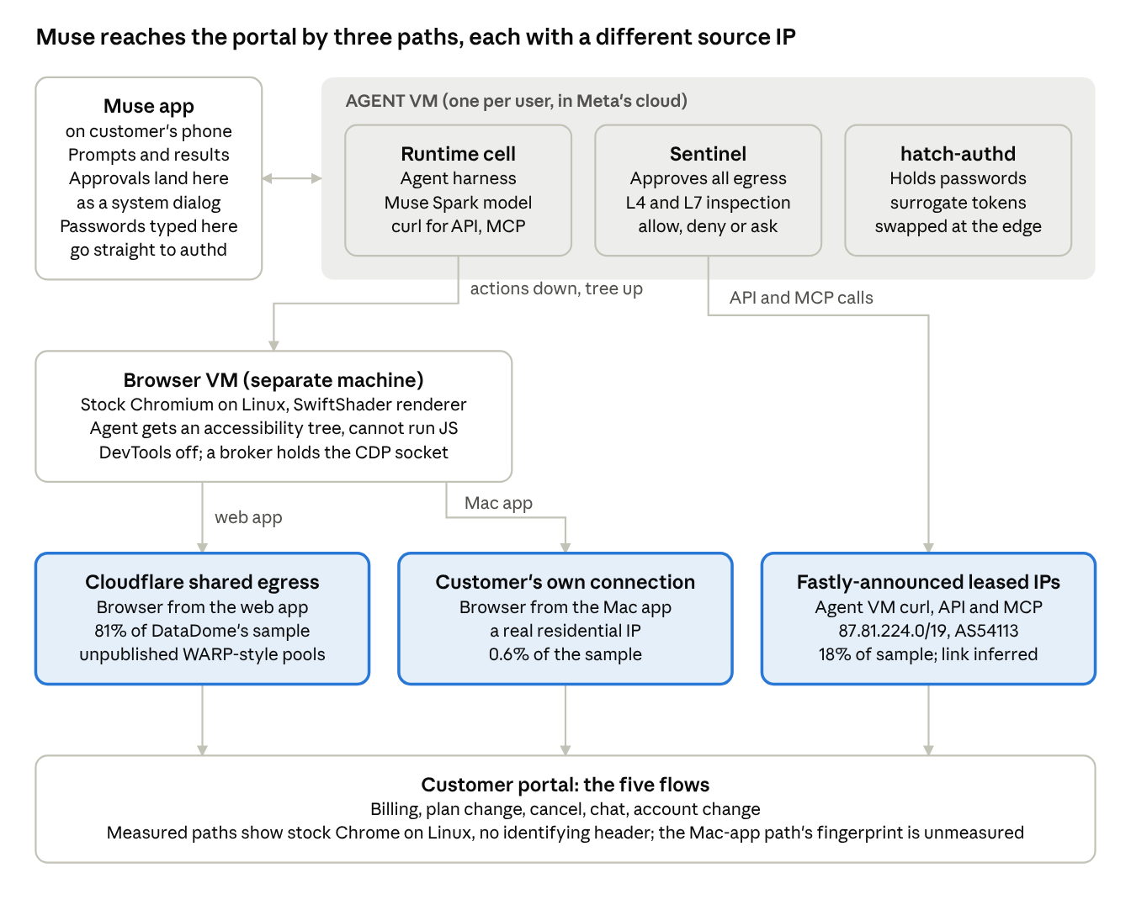
Muse request path · Meta's architecture post plus Loosemore, Stark Insider and DataDome measurements
The browser and the agent VM are different machines with different exits, and the Mac app sends the browser out through the customer's own line, so no single IP rule covers Muse.

Egress: three paths, three measurements
Path | Evidence | Source
Browser from the web app: Cloudflare | DataDome's sample is 81.2% Cloudflare; an observed browser exit IP, 104.28.208.216, sits inside CLOUDFLARENET 104.16.0.0/12 but outside Cloudflare's published reverse-proxy list, consistent with Cloudflare's unpublished shared egress pools (WARP, Zero Trust, Browser Rendering), which Cloudflare's docs say are never published | DataDome Q3, Stark Insider, Cloudflare docs
Agent VM API and MCP calls: Fastly-announced leased space | 18.1% of DataDome's sample is Fastly; the agent's own curl traffic came from 87.81.224.0/19, about 8,000 addresses RIPE-registered on Sept 21, 2026 to an anonymized "Private Customer" but BGP-originated by AS54113 Fastly; 21 requests arrived from 21 distinct IPs, so the pool is shared and rotated per request | Loosemore, Oct 9, bgp.tools
Browser from the Mac app: the user's own connection | "Run from the Mac app, Muse's browser goes out through whatever connection the user is on"; a UK tester's browser left through his own broadband line. This reconciles DataDome's 0.6% consumer-ISP tail (Comcast, Verizon, AT&T, Charter among them) and Profound's "residential" claim | Loosemore, Profound, Oct 2
Three consequences. A rule keyed on Cloudflare's published IP list will miss Muse; the signal is BGP origin ASN (AS13335, AS54113) with per-prefix review, not WHOIS names. The same Muse task can reach a portal from two providers if it exposes both HTML and JSON endpoints. And residential-IP trust cannot exclude Muse, because the Mac app path arrives from a real customer address. Meta has published nothing about egress providers, ranges or sharing.

Identification: what the browser says about itself
No source has captured a verbatim full User-Agent, but three independent observers agree on the profile (Stark Insider, Loosemore, DataDome):
Attribute | Observed value
User-Agent and Client Hints | Stock desktop Chrome on Linux x86_64: Chrome 153 at launch, 154 by Oct 9; Sec-CH-UA-Platform "Linux"; hints agree with the UA
Custom headers, cookies, signatures | None; no Web Bot Auth
Automation flags | navigator.webdriver false, "no automation leftovers"; page JavaScript runs normally
Renderer | SwiftShader (software), identical every session
Hardware | 6 cores, 16 GB
Fonts | Liberation Sans, Noto Sans, Noto Color Emoji and common aliases
Timezone and language | Follow the user, not the exit IP (en-GB and Europe/London for a UK user behind a US exit)
Window | Varies between sessions, sometimes wider than the screen
Fleet behavior | DataDome: "live Muse sessions on unrelated sites showed nearly identical values"; Cequence saw a browser version go from 0% to over 90% of Muse traffic within days; Fingerprint says Muse "alters its browser fingerprint and suppresses the automation flags"
The agent VM's non-browser path is different: curl/8.5.0 over HTTP/1.1 with curl's default header order, a JSON content type, a fresh Idempotency-Key per lookup, and X-Agent: Muse when a site's plain-text API guide asked for it; by Oct 9 it sent X-Agent: Muse unprompted on every API and MCP call, and opened MCP sessions as client muse-curl, skipping the initialize handshake (Loosemore). Meta has also stated support, with Shopify and Stripe, for an unpublished "Personal Agent Protocol" for agent self-declaration; if Muse adopts it, the browser-path problem shrinks considerably.
Meta's declared crawlers are not Muse. The documented tokens are facebookexternalhit, meta-webindexer, meta-externalads, meta-externalagent and meta-externalfetcher; Meta-ExternalFetcher "fetches individual links at a user's request" for agentic features and may bypass robots.txt (Meta web crawlers). Profound saw meta-webindexer hits from non-Meta IPs immediately before Muse visits, up 1,313% on US and Canadian retail sites after launch, but calls this a proxy signal, not proof.

Behavior on third-party sites
- Prefers an API when one exists. "Given a free choice, Muse skipped the browser and used the API every time. It said it found the API more reliable." It remembers prior sessions and shortens repeat flows.
- Interaction cadence. Types every character as a real keypress at 62 to 86 ms intervals with 28 to 39 ms holds; 1 to 3.5 mouse moves per click with no curved bursts; never pastes; fixed four-second waits before status checks. One tester, one task type; validate in the lab.
- Logins. Arrives logged out, stalls at the login step until the customer supplies credentials through the Muse client, then proceeds with the password injected by authd. One tester hit Google's "it's me" confirmation loop three times. DataDome's sample contained about 24,800 login requests, 9,600 payment and 6,800 account-creation requests even though Muse "mostly acts logged out". Cequence observed Muse completing MFA at financial institutions.
- Diurnal. Volume rises from 08:00 UTC and peaks at 16:00 UTC: user-driven, not scheduled.
- Unknown. No source documents how Muse reacts to a CAPTCHA, a WAF challenge, or an "automation not authorized" notice, nor its handling of SMS, TOTP or push MFA. Because page content is treated as untrusted and screened by injection classifiers, a notice phrased as an instruction to the agent may be ignored or flagged rather than obeyed; a hard gate at the login step is more likely to produce a hand-off to the user. Experiments 1 and 2 in the lab plan measure both.

Connector program
platform.muse.ai opened with terms effective Sept 18, 2026. Connectors are defined to include MCP servers; Meta reviews each "for functional, security, and legal requirements" with end-to-end testing, approved connectors appear in Muse's directory, non-deterministic skills "must define a bounded action range," scraping is prohibited, and Meta may remove a connector at any time (terms). Reviewed connectors run in privsep workers with surrogate credentials rather than in a browser session with an injected password. Muse for Small Business (Sept 29) confirms custom connectors exist, but the help-center article describing them is JS-rendered and could not be read, so three claims from the earlier plan are unverified: that Muse builds API, CLI and MCP clients and saves them as skills; that Meta does not review custom connectors; and the OAuth redirect URI https://agent.meta.ai/api/hatch/oauth/callback. The "hatch" naming makes the URI plausible, but it must be confirmed from a live OAuth flow before it is used as an indicator. Muse Code, the terminal tool, documents MCP over stdio and streamable_http with OAuth 2.1, and states that "MCP tools are not sandboxed."

Roadmap items that change the signals
Item | Status | Effect on detection
Confidential VM | "Later this year"; testers already on it; external audit planned | Changes Meta's access to VM data, not the browser's network identity; site-side detection remains the control point
Muse Wonder model (Oct 12) | "Will soon power experiences in Muse" | May change cadence and planning behavior, not headers; re-validate behavioral signals after rollout
Personal Agent Protocol | Meta stated support, spec unpublished | If adopted, Muse self-declares and the attribution problem becomes a verification problem
Egress tightening | Internal post (Sept 18) on constraining the ports and IPs Hatch hosts can reach | Egress pools may change; the drift monitor must track ASN and prefix churn
Availability | US (Sept 8), US and Canada (Sept 29), UK use observed Oct 9 | Volume growth continues along DataDome's early 18%-a-day curve
Bug bounty | Up to $300,000 for VM escape, $130,000 for single-user prompt injection | Irrelevant to the lab, which does not probe Meta's defenses

OpenClaw lineage
Meta's Nat Friedman said on Sept 21: "We built Muse from scratch, but it is definitely heavily inspired as a product by OpenClaw." OpenClaw's browser tool is Playwright over CDP against a managed Chromium profile, headless by default, with an accessibility-snapshot and reference model (e12, axN), arbitrary JavaScript evaluation on by default, and support for hosted stealth browsers through a cdpUrl (Browserbase, Notte). Muse kept the snapshot-and-reference model and removed JavaScript evaluation and DevTools from the agent. The OpenClaw tells seen in the same testbed, HeadlessChrome/155, a UTC clock, an 800 by 600 viewport and a companion undici fetch beside each page, are absent in Muse. Treat OpenClaw as the comparator for the broader class, not as a proxy for Muse's fingerprint.

Open items
- No verbatim UA string, Accept headers or TLS fingerprint published anywhere; the lab captures them on day one.
- Which Cloudflare and Fastly products carry the egress; whether iOS and Android apps route the browser through the user's connection as the Mac app does.
- The Mac-app browser path's UA, renderer and fonts are unmeasured; if the Mac app drives a local browser, the environment and egress signal layers do not apply to that path.
- Amazon never disclosed how it detects Muse.
- The custom-connector mechanics and the OAuth callback URI.
- Whether Muse's browser fetches robots.txt at all.

Landscape: what already exists and the precise gap
Three things already exist: a cooperative identification standard that Muse does not use, five vendors that have attributed Muse behaviorally since about September 22, and peer companies that have chosen to block, to channel, or both. What does not exist is a published, reproducible Muse signature set, or anything native to F5 and Akamai that attributes Muse and drives a graduated response.

Cooperative identification: Web Bot Auth
The standard is deployable but unfinished. The IETF webbotauth working group was chartered in October 2025 and adopted its first Standards-Track document, draft-ietf-webbotauth-httpsig-protocol-00, on September 1, 2026; its April 30 and August 31, 2026 milestones were missed. Mechanics: Signature, Signature-Input and Signature-Agent headers per RFC 9421, tag web-bot-auth, Ed25519 keys published at /.well-known/http-message-signatures-directory. One wrinkle matters for any verifier: the WG draft mandates the dictionary form of Signature-Agent, while Cloudflare's live verifier rejects it and requires the bare quoted string, so a verifier must accept both.
Role | Who, as of October 2026 | Source
Signs requests | OpenAI ChatGPT cloud browser (Signature-Agent: "https://chatgpt.com"; 78.4% of its sessions signed), Google-Agent (experimental, a subset), Amazon Bedrock AgentCore Browser (opt-in), Browserbase, Anchor, Block Goose, Manus | Arkose Q3 2026, Google, AWS
Does not sign | Meta (Muse presents as plain Chrome and signs nothing), Anthropic (Claude in Chrome sends normal Chrome identity from the user's IP), Perplexity Comet, Apple, Mistral | Oct 19 probe of 150 operators, DataDome Q3
Verifies at the edge | Cloudflare (cf.bot_management.signed_agent; signed agents are Verified bots labeled Intermediary since July 1, 2026), AWS WAF Bot Control (since Nov 2025; labels web_bot_auth:verified/invalid/expired/unknown_bot), Akamai, HUMAN, DataDome, Fingerprint, Kasada; F5 is listed as a verifier by AWS AgentCore. No evidence for Fastly or Google Cloud Armor | Cloudflare, AWS, OpenAI allowlisting page
Only 2.3% of legitimate agent sessions carried a verified signature in Q3 2026 (Arkose, Oct 20). Web Bot Auth therefore cannot detect Muse. Its value here is to carve cooperative agents out of the pool, route them to the declared channel, and be ready the day Meta signs. The commerce protocols (Visa Trusted Agent Protocol, which reuses the Web Bot Auth wire format; Mastercard Agent Pay; AP2, donated to the FIDO Alliance on April 28, 2026; ACP from Stripe, OpenAI and Meta) identify agents at checkout, not on the account pages of a non-merchant site. The working group's own list is now debating per-user keys and a "human-principal layer": every standard today identifies the operator, never the customer behind the agent.

Vendors: who names Muse today
Five vendors publish evidence of naming Muse, all on fingerprint and behavior rules, all live on or about September 22, two weeks after launch. None discloses its method or sample sizes.
Vendor | Layer | Named Muse detection | Web Bot Auth | Policy vocabulary | Note
DataDome | Server-side module plus JS tag | Yes, as "agentic browser" (nine days of September) | Verifies | Allow, Block, Rate Limit, Time-Box, Intent-Based, Monetize; agent, endpoint and custom levels | Forrester Leader; claims FP rate under 0.01%; report never mentions WARP, Private Relay, VPN or fingerprints
HUMAN Security | Network behavioral plus sensor | Yes; blocks Muse by default | Verifies | Agent Trust Levels High/Medium/Low; per-action permissions (content, engage, account creation, checkout, rate limit) | Forrester Leader; names Muse and 30+ agents
Arkose Labs | Browser-side risk plus challenges | Yes; back-filled from stored fingerprints, exact match from Sept 26 | Verifies | Self-disclosing / non-disclosing / malicious populations | Strong Performer; 59% of Muse sessions from hosting IPs vs 4.3% for people
Fingerprint | Client JS plus server API | Yes since Oct 6: bot_type: meta_muse, identity: unknown | Verifies | Confidence high/medium/low | Notes Muse changes its fingerprint and suppresses automation flags
Cequence | API security | Yes, behaviorally | Not stated | "Block the action, not the agent" | Saw a browser version go 0% to 90%+ of Muse traffic in days (centrally updated fleet), consumer-VPN routing, and Muse completing MFA at financial institutions
Cloudflare | Edge plus Turnstile; Precursor session analysis (July 2026) | No public naming found, although 81% of Muse egresses through its network | Verifies | Agent/Training/Search presets; detection IDs per named bot | Default-blocks Agent traffic on ad pages for domains onboarded since Sept 15, 2026
Kasada | Edge | None published | Supports | Verified agent directory, policy controls | Forrester Leader; no Muse detail
AWS WAF Bot Control | WAF | None | Verifies | 650+ named bots and agents; Category:AI allows verified agents by default | No behavioral agentic-browser claim
Imperva | WAF plus edge | None published | Not stated | 700+ dimensions | Agent-level documentation not public
cside | Browser tag | None | No | Session verdict API | "81% bypass" claim has gated methodology
F5 and Akamai are covered in the detection-architecture section. One Akamai data point belongs here: more than 98% of requests from agentic browsers such as Comet and Atlas carried little or no mouse movement, and Akamai's legacy mouse models flagged under 1% of them (secondary source: ScrapingBee, Oct 2).

What the measurements say
Muse arrived at mass-market scale within days. DataDome counted 29.1 million Muse requests on its network between September 22 and October 3, rising from 0.8 million to 3.7 million a day in nine days, with a peak of 484,000 in one two-hour window and a daytime-US diurnal curve. September agentic-browser traffic on that network rose 4.7x to 58.2 million requests: ChatGPT's cloud browser 27.4 million, Muse 19.5 million, Claude's browser extension 10.5 million, Comet 0.8 million (DataDome Q3 2026). HUMAN's September ranking is drawn below.
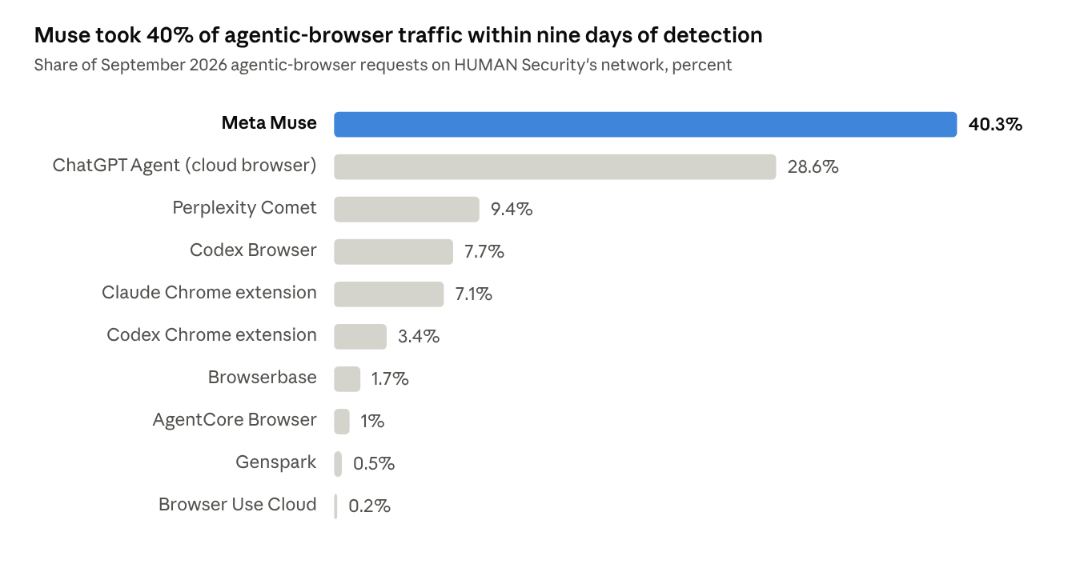
HUMAN Security, State of Agentic Traffic, September 2026 · 10 named agents
On HUMAN's network Muse was the largest single agentic browser in September, at 40.3% against 39.7% for OpenAI's three products combined; on DataDome's network ChatGPT's cloud browser led.
Account-management flows are a small slice of a very large number. In HUMAN's data Muse spends 84.3% of requests on products and search, 2.6% on checkout and payment, 1.7% on user-account pages and 1.1% on authentication (HUMAN, Oct 5). In DataDome's sample 8.9% of Muse requests hit sensitive endpoints, and forms dominate that slice.
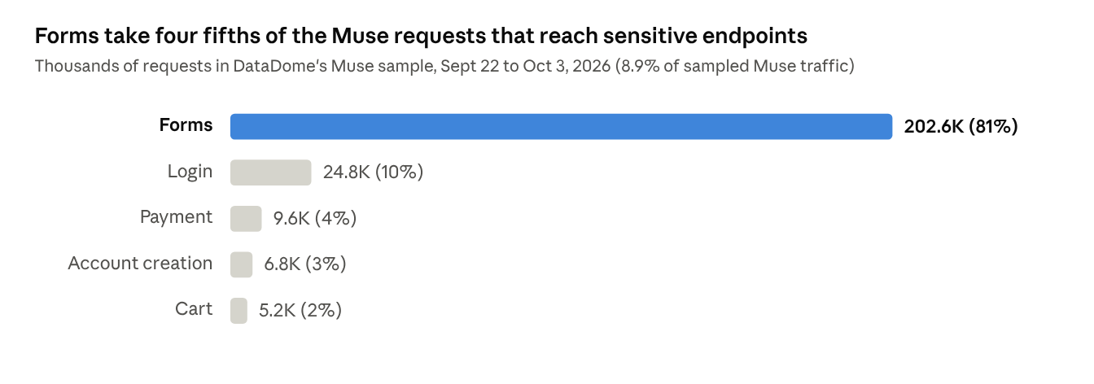
DataDome AI Traffic Report Q3 2026 · sample of Muse traffic, sample size not published
Logins are a tenth of the sensitive slice and payments a twentieth, so a portal will see Muse mostly filling forms inside sessions it already holds.
The egress evidence conflicts, which is why the lab has to measure rather than assume. DataDome's sample is 99.3% cloud and CDN infrastructure (Cloudflare 81.2%, Fastly 18.1%) with 0.6% from eight consumer ISPs including Comcast, Verizon, AT&T and Charter. Arkose puts 59% of Muse sessions on hosting IPs on its protected login, registration and checkout flows. Cequence describes each user's cloud-hosted Chrome as routed through a consumer VPN, and Profound reportedly sees residential connections. A share of Muse traffic looks residential to someone, and all of it shares IP space with Cloudflare WARP, Apple Private Relay and Cloudflare Workers.

The precise gap
- No published, reproducible Muse signature set. Every vendor naming Muse went live around September 22 on proprietary rules; none publishes its method, and DataDome's report never mentions WARP, Private Relay, VPN, JA4 or fingerprints.
- Conflicting egress evidence: 99.3% CDN versus 59% hosting versus residential claims, plus the consumer-VPN observation. The IP prior must be measured on the portal's own traffic.
- Nothing native to F5 or Akamai names Muse today. The response ladder (interstitial, step-up, MCP redirect) is bespoke everywhere.
- Identity standards identify the operator, never the customer; the human-principal question is unresolved at the IETF.
- Vendors report Muse as hardened: Fingerprint says it suppresses automation flags and changes its fingerprint, and Cequence says it completed MFA at financial institutions; both are vendor claims, unverified here. The naive checks fail; durable attribution needs the fleet-level and behavioral signals in the signal catalog.

Signal catalog and attribution model
The cheap automation flags do not identify Muse, and the interaction shape collides with screen-reader users, so attribution rests on a conjunction: an honest Linux cloud-VM environment, egress from shared CDN pools with Private Relay subtracted, Playwright-style input artifacts that assistive technology does not produce, fleet-identical fingerprints across accounts, and the session-level pattern of a never-seen device and ASN logging in and going straight to a sensitive write. Each signal below carries its collection point, the expected Muse-class value, its robustness, and the cohort it collides with. The lab measures which of these Muse actually exhibits; nothing here is a finding until it does.

Why the obvious checks fail
navigator.webdriver, the HeadlessChrome token, a missing window.chrome, empty plugin arrays and the Chrome-for-Testing brand are all removed by a launch flag or a patched library. Muse already reports webdriver false with "no automation leftovers." The strongest protocol-level tell of the last two years, the Runtime.enable console-serialization leak, was silently broken for naive implementations by two V8 commits on May 7 and 9, 2025 (Castle, Aug 2025); a new variant using a Proxy ownKeys trap and console.groupEnd was published in March 2026 and is unpatched so far, but rebrowser-patches, Patchright and nodriver avoid Runtime.enable altogether and claim to pass Cloudflare, DataDome, Kasada, Akamai and F5. Whether Meta's broker enables the Runtime domain is a first-day lab test, not an assumption. Fingerprint reports that Muse "alters its browser fingerprint and suppresses the automation flags" (Fingerprint, Oct 6).

Layer 1: environment (hard to fake, because faking it means lying about the OS)
Signal | Collected at | Muse-class value | Human value | Robustness | Collides with
Sec-CH-UA-Platform and frozen UA platform | HTTP, JS | "Linux"; X11; Linux x86_64 (Chromium source literals) | Windows, macOS, iOS, Android; Safari and Firefox send no Client Hints | Moderate alone; strong cross-checked against high-entropy hints | Linux desktop humans: 4.54% of desktop share (StatCounter, Sept 2026), 2.9% of screen-reader users
WebGL vendor and renderer | JS (WEBGL_debug_renderer_info) | SwiftShader software renderer, or no WebGL at all on a GPU-less VM | ANGLE Metal, D3D11, Adreno, Mali, Apple GPU | Strong: renaming the string leaves extensions, texture limits, shader precision and rendered pixels contradicting the claim (Castle) | VDI and remote-desktop users, hardware acceleration disabled
Installed font set | JS | Linux markers: Liberation, Noto Color Emoji, DejaVu, Arimo, Cousine (CreepJS) | Segoe (Windows), Helvetica Neue and Apple SD Gothic (macOS), Roboto (Android) | Strong against UA spoofing in Chromium stacks | Linux desktop humans
OS-consistency lies | JS | None if Muse reports Linux honestly; contradictions if Meta ever spoofs Windows | Consistent | Strong when spoofed, irrelevant when honest | None
Hardware and memory | JS | 6 cores, 16 GB, identical every session; Battery API reports a fully charged plugged-in battery (the no-battery default) | Varied; desktops share the battery value | Weak alone, strong as a fleet signal | All desktop PCs on the battery value
Timezone and language versus egress IP | JS plus edge | Follow the customer, not the exit IP (en-GB and Europe/London behind a US exit) | Consistent | Moderate | Travelers; Private Relay keeps the user's region so does not mismatch; WARP may
Canvas | JS | Software raster differs from hardware output | Hardware | Moderate; randomization itself is detectable | Firefox, Brave and Samsung Browser randomize on purpose
Clean cold-start profile | JS, network | Fresh VM: no extensions, no cached assets, no history | Varied | Weak alone | Private-window users
TCP stack | Edge (L3/L4) | Linux: TTL 64, options MSS, SACK, timestamp, NOP, WSCALE | Windows TTL 128 | Moderate; invisible behind a CDN or TLS-terminating proxy | macOS and Linux humans share TTL 64

Layer 2: network egress (a prior, never a verdict)
Signal | Muse-class value | Collides with | How to subtract
BGP origin ASN 13335 (Cloudflare) or 54113 (Fastly) | 99.3% of DataDome's sample; Cloudflare's shared egress pools are unpublished, so the published reverse-proxy list misses them; Fastly space is RIR-registered to an anonymized lessee | iCloud Private Relay exits through Cloudflare /32s, Fastly and Akamai (APNIC); consumer WARP shares Cloudflare egress and Cloudflare publishes no WARP list; enterprise proxies | Private Relay: match against Apple's CSV, refreshed daily (prefixes /27 to /32, geolocated to the user's region). Private Relay carries Safari, Apple-app and DNS traffic, never Chrome, so a desktop-Linux Chromium UA from a relay-listed address is not a relay user. WARP: vendor relay labels only
Residential ISP | 0.6% of the sample; the Mac-app browser path exits through the customer's own line | Every real customer | Cannot be subtracted; residential trust must not exclude Muse
TLS (JA4) and HTTP/2 fingerprints | Chromium and BoringSSL defaults, identical across Chromium-based agents in the one study that measured them (arXiv 2606.20910) | Every Chrome user | Not discriminative for Muse; collect them to detect whether Sentinel ever re-terminates TLS, which would be a strong tell
Sec-Fetch and Client-Hint coherence | Unmeasured for Muse; Browser Use violated Sec-Fetch logic in 100% of requests, Operator in 41% | None | Low cost to log
Web Bot Auth signature | Absent for Muse; present for the ChatGPT cloud browser | None | Positive identification of cooperative agents only

Layer 3: interaction (where the screen-reader trap lives)
Chromium's own source settles what a screen reader's click looks like: an assistive-technology "do default action" is synthesized as pointerdown, mousedown, pointerup, mouseup, click, with isTrusted true, pointerType "mouse", detail 1, and coordinates at the exact center of the element's border box, with no preceding hover or mouseover (an open Chromium bug, 1171924) (simulated_event_util.cc). Playwright's click() targets the center of the first content quad with one teleporting mousemove and no delay (Playwright). A Meta patent, US10530872, uses exactly these "impossible event values" to infer screen-reader use. So "exact-center click, no hover, no wheel" is shared by assistive-technology users and accessibility-tree agents, and a rule built on it reproduces the 2021 Adobe WebsiteBot mistake of flagging keyboard-only users.
Artifact | Playwright-style agent | Screen reader via Chromium accessibility | Keyboard-only human | Use
Click coordinates | Exact center of the content quad | Exact center of the border box | Not populated | Shared: do not use alone
Preceding mousemove | Exactly one, at the destination, no intermediate points | None | None | Separator: one teleport move before a click is automation
Typing | fill emits one input event for the whole string with no key events; type emits key events at 0 ms | Real key events with human cadence (inference, to be measured) | Real key events | Separator: input without keys, or key cadence in a fixed 60 to 90 ms band with 28 to 39 ms holds (Muse, one tester)
Scrolling | scrollIntoView; no wheel events in any of 1,025 agent sessions (TUM) | Focus-driven, typically no wheel | Keyboard, no wheel | Shared: do not use alone
Timing | Seconds of think time then sub-second actions; dominant for identifying which model is driving (96% F1) but the easiest to perturb (arXiv 2605.14786) | Human | Human | Low weight
Paste and autofill | Muse never pastes; password managers produce bulk fills | Varied | Varied | Weak
Session evolution | Static or mechanically adjusted signals across actions (HUMAN) | Gradual human variation | Gradual | Moderate
Akamai measured 63.2% of agentic requests from Comet and Atlas carrying zero mouse events, and its prior mouse model flagged under 1% of them; a small transformer reached ROC-AUC 0.981 but only PR-AUC 0.661, with overlap on sparse human sessions (Akamai Security Research, Aug 2026, a research post rather than product documentation). No published study has evaluated any agent detector against real screen-reader users; the literature's human baselines are CAPTCHA mouse sessions and 30-person lab panels.

Layer 4: session and fleet (the signals only the team can build)
- New device, straight to a sensitive write. A device, ASN and fingerprint the account has never seen logs in and proceeds directly to a plan change or cancellation, judged against the account's own history of devices and networks. Muse mostly acts logged out, so this fires on a minority of sessions, and exactly the risky ones.
- Fleet similarity. DataDome saw "nearly identical values" across Muse sessions on unrelated sites; Cequence saw one browser version go from 0% to over 90% of Muse traffic within days. Attribute homogeneity across many accounts, and synchronized change-points, are a signature no human cohort shares.
- Cold start with purpose. A fresh profile with no cookies, cache or extensions that proceeds directly to a form on a sensitive flow.
- Egress rotation inside a session. 21 requests from 21 distinct addresses in one shared pool.
- Cross-path arrival. The same task reaching HTML endpoints from Cloudflare space and JSON or MCP endpoints from Fastly space.
- Diurnal. Volume following US daytime, not a scheduler.
- Content. LLM-authored register in chat transcripts (Binoculars detects over 90% of ChatGPT output at 0.01% false positives on documents, untested on short support turns), and agent self-identification in chat.

Layer 5: cooperative identity
Web Bot Auth signatures, the X-Agent: Muse header that Muse sends on API and MCP calls, the muse-curl MCP client name, and the connector OAuth callback once confirmed. These identify the operator, never the customer, and only cover the paths Muse chooses to declare.

Traps and honeypots
A hidden-but-accessible element is perceived identically by an accessibility-tree agent and a screen reader; the Meta patent uses clicks on imperceptible links as screen-reader evidence. To catch the agent without the assistive-technology user, an element must be excluded from the accessibility tree, which also removes it from the agent's snapshot. Hidden-element traps are therefore structurally weak against Muse-class agents and reserved for Experiment 3, where their false-positive cost on screen-reader users is measured before any use. In-page instruction tests are prompt injection against a third party's agent acting for a customer (Brave's Comet demonstration used white-on-white text to exfiltrate an OTP), so Experiment 1 limits them to self-identification and redirection notices.

The attribution model
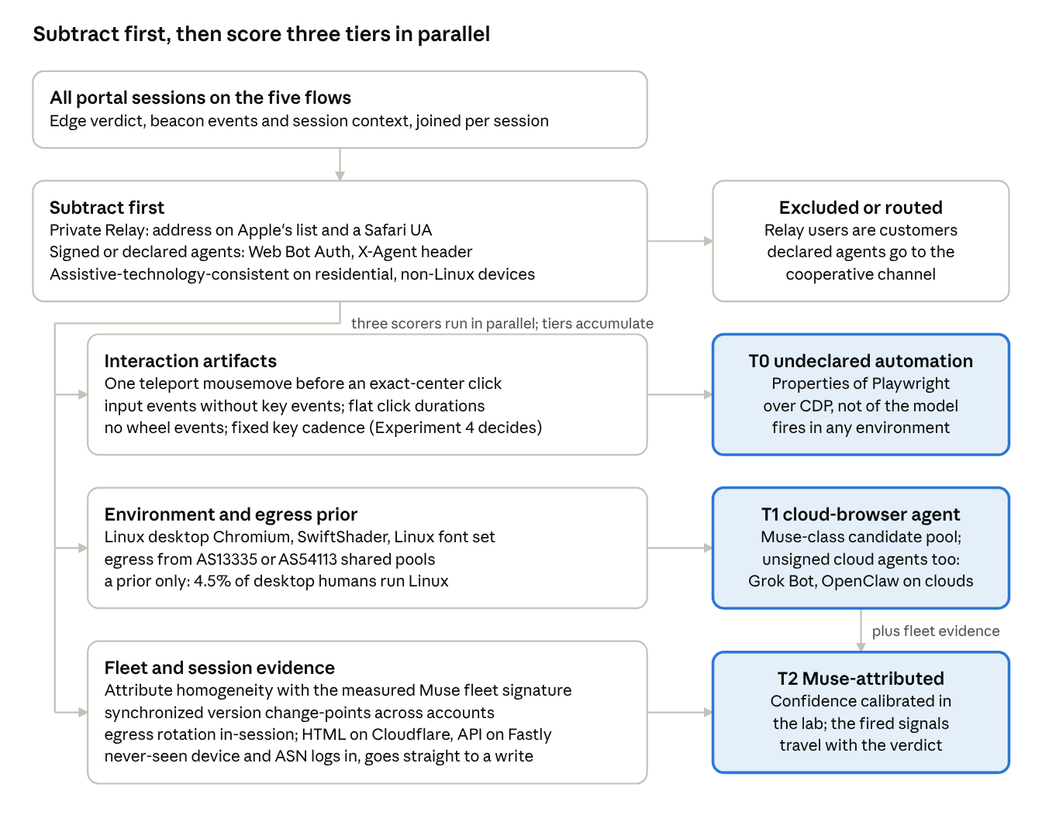
attribution model · one subtraction stage, three scoring stages, three tiers
Tiers accumulate rather than exclude: a session can be T0 and T1 and T2 at once, and the subtraction stage runs before any scoring so relay users and screen-reader users never enter the pool.
Scoring rules:
- Subtract first. Remove Private Relay (Apple's list plus a Safari UA), declared and signed agents (routed to the cooperative path), and sessions whose interaction shape is consistent with assistive technology and whose environment is residential and non-Linux. Nothing downstream scores these.
- Environment plus egress sets the prior. Linux desktop Chromium with a software renderer and a Linux font set, arriving from AS13335 or AS54113 shared pools, is the T1 candidate pool. On its own it is a prior; 4.5% of desktop humans run Linux.
- Interaction confirms automation (T0). A teleport mousemove before center clicks, input without key events, flat click durations, no wheel events and fixed inter-key cadence raise the session to T0 whatever the environment. These are properties of Playwright-over-CDP, not of the model; Meta would have to add synthetic travel and scrolling to remove them. One caution: the single tester who measured Muse saw real keypresses at 62 to 86 ms and one to three mouse moves per click, so two of the four separators may not fire on Muse as shipped; Experiment 4 decides which do.
- Fleet and session evidence makes it Muse (T2). Attribute homogeneity with the measured Muse fleet signature, synchronized version change-points, egress rotation within the session, cross-path arrival, and a never-seen device and ASN logging in and going straight to a sensitive write promote T1 to T2 with a confidence that the lab has calibrated.
- Every tier carries its evidence. The list of signals that fired travels with the verdict into the response ladder and the data lake.

What changes when Muse changes
If Meta adds synthetic mouse travel and scrolling, Layer 3 degrades and Layers 1, 2 and 4 carry the weight. If Meta spoofs Windows, Layer 1 gets stronger, since the forged fingerprint contradicts itself. If Meta adopts Web Bot Auth or the Personal Agent Protocol, Layer 5 takes over and the problem becomes verification. If egress moves to residential proxies at scale (Castle found 84.7% of one "private" proxy network's exits already attributed to named operators), Layer 2 weakens and the fleet signals in Layer 4 become the primary attribution.

Detection architecture on standard products
F5 and Akamai both ship the enforcement plumbing the response ladder needs, and neither ships the detection: no F5 or Akamai document names Muse, OpenClaw, Claude in Chrome, Grok or Atlas, neither documents detecting accessibility-tree or CDP-driven interaction in a real Chromium, and neither recognizes an agent entering an already-authenticated human session as a state of its own. The design that follows uses the vendor for signal collection and enforcement, and puts attribution in a session-scoring layer the team owns.

What each product can and cannot do
Evidence is tagged by strength: documentation, datasheet, press release, blog. Vendor marketing claims without a documentation page are marked as unverified.
Capability | F5 (XC Bot Defense, BIG-IP AWAF) | Akamai (Bot Manager, App & API Protector, Account Protector, EdgeWorkers)
JS sensor and device signals | Shipped: JS and mobile SDK telemetry attached as headers or POST body; inline verdict human/automated (docs) | Shipped: injected script, browser fingerprinting, behavioral anomaly detection (product page); Content Protector adds headless detection "including in stealth mode" (product page)
Behavioral biometrics (mouse, keyboard, touch) | Claimed in blogs as "interaction telemetry"; not itemized in docs (blog) | Shipped, Bot Manager Premier only, on transactional endpoints such as login and checkout (docs)
Persistent device ID and device risk | BIG-IP Device ID shipped; XC device intelligence (persistent ID, emulator and spoofing risk) is limited availability Q4 CY2026 (press) | Shipped: Account Protector user UUID and risk score (docs)
TLS and HTTP/2 fingerprints | JA3 matcher in XC service policies (docs); HTTP/2 not documented | SIEM fields identity.ja4, identity.tlsFingerprintV2/V3 (schema); HTTP/2 fingerprinting is 2017 research, product use unconfirmed
ASN and IP conditions | Shipped: BGP ASN lists and sets, IP prefixes, JA3, path, header and JWT matchers in one service policy | Known-bot definitions use ASN; App & API Protector ASN condition not confirmed; EdgeWorkers user-location object exposes no ASN (docs)
Agent class model | "Humans, trusted AI agents, malicious bots" declared available Sept 15, 2026 (press); classification is category-level, never a named agent (blog) | Bot directory split Sept 3, 2026 into AI training crawlers, AI search crawlers, AI fetchers and agents, covering declared agents only (blog)
Named attribution of Muse | Not documented | Not documented; an undeclared Chromium lands in "unknown" or transparent detection
Web Bot Auth verification | Claimed in an April 2026 blog, no documentation found: unverified | Stated live at the edge since Nov 2025, validated traffic classed "validated-bot" with allow, challenge, delay or block (blog); no field name documented
Tag to origin | Shipped: Continue with mitigation headers; Transform adds inference and automation-type headers (docs) | Shipped: Akamai-User-Risk header (uuid, score, risk, trust, action) (Ping connector docs); Client Reputation forwardToHTTPHeader
Custom interstitial | Shipped: Block with custom status, headers and body; Redirect; BIG-IP BOTDEFENSE::action custom_response (docs) | Shipped: Serve alternate, Custom deny, EdgeWorkers respondWith with a 16,384-character body cap (docs)
Step-up authentication | App-side: origin reads the Transform or Continue headers; "step-up challenge" is a press-release term with no doc page | App-side: Ping consumes Akamai-User-Risk (defaults 25 medium, 50 high) (blog)
Delay, tarpit, rate limit | BIG-IP rate-limit (30 TPS default), honeypot page, TCP reset; XC documents only Continue, Block, Redirect, Transform | Shipped: tarpit, delay, slow, serve cached content (SIEM actions)
Edge custom logic | BIG-IP iRules: 25 BOTDEFENSE:: commands including bot_anomalies, device_id, intent, client_class (docs) | EdgeWorkers onBotSegmentAvailable reads request.botScore.responseSegment (human, cautious, strict, aggressive, safeguard) and can respondWith, but cannot set headers in that handler (docs)
SIEM export | Destinations documented (Splunk, Sentinel, Datadog, Devo, buckets); field names not public | Fields documented: botData.botScore, botData.responseSegment, clientData.telemetryType, identity.ja4, clientReputation, userRiskData.*
Fail mode | CDN connectors fail open after a 700 ms timeout: no header means unknown, not human | "No latency" claimed, no figures
Private Relay stance | None found | Akamai operates Private Relay egress and advises against IP-dependent logic (blog, 2022)
Two roadmap items matter. F5's device-intelligence add-on, which brings a persistent device ID and emulator or spoofing risk scoring, is the single most relevant feature for spotting cloud-VM Chromium and reaches limited availability in Q4 2026. Akamai's June 2026 Agentic Security Framework (KYA, Visa TAP, Auth0 and Ping, TollBit and Skyfire, TrafficPeak) is aimed at legitimizing declared agents, not hunting undeclared ones, and has no GA dates. Akamai's own research concedes that agents "mimic human microbehaviors" and create a "signal masking problem" (press, July 2026).

Reference architecture
The design has four planes. The vendor collects signals and enforces; a session-scoring service the team owns joins vendor verdicts to identity and session context and produces the T0/T1/T2 tier; the application consumes the tier at the five flows; a data lake holds every verdict with its evidence for the lab, the dashboards and the drift check.
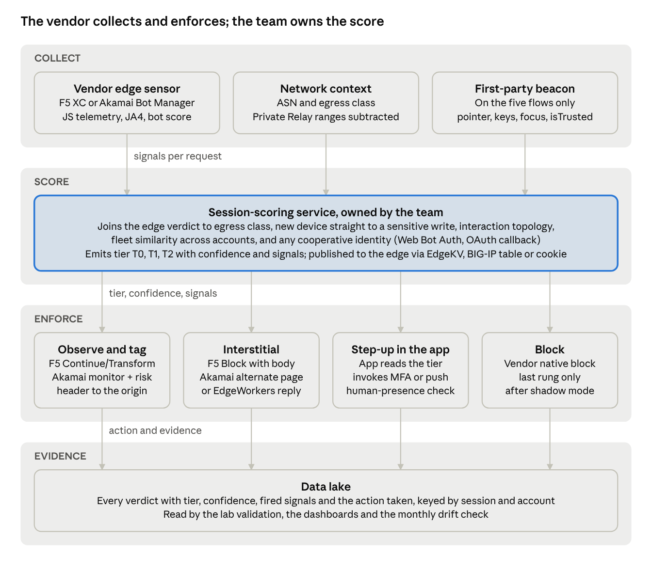
reference detection architecture · 4 planes, 9 components
Signals flow down from the vendor sensor, the network context and the first-party beacon into the team's scoring service, which picks the rung; every rung writes its evidence to the lake.
Collection. Keep the vendor JS sensor on every portal page, including the authenticated ones, since the five flows all sit behind login. Add the fields the vendor does not expose by default: on Akamai, ja4, botScore, responseSegment, clientReputation and userRiskData into SIEM; on F5, the Transform headers logged at the origin and the Data Intelligence add-on. Add a lightweight first-party interaction beacon on the five flows (pointer travel, keyboard cadence, focus and scroll timelines, isTrusted, viewport and renderer) because neither vendor documents accessibility-tree or CDP artifacts as inputs, and those are the Muse-specific signals in the signal catalog.
Scoring. The vendor verdict is one input, not the decision. The session-scoring service joins, per authenticated session: the edge verdict and score; ASN and egress class with the Apple Private Relay egress list and Cloudflare WARP ranges subtracted; whether the device and ASN that logged in have ever been seen on the account, and whether the session goes straight to billing or cancel; interaction topology from the beacon; fleet signals (identical browser builds and sequences across many accounts, which is how Cequence saw a browser version go from 0% to 90% of Muse traffic in days); and any cooperative identity (Web Bot Auth signature, the agent.meta.ai OAuth callback on the declared channel). It emits a tier, a confidence and the list of signals that fired, and publishes the tier where the edge can read it in under 10 ms: on Akamai an EdgeKV entry keyed by session that the EdgeWorker reads, on F5 a BIG-IP session-table entry or a signed session cookie set by the origin; where neither is available, the application serves the interstitial itself.
Enforcement. Observe and tag ride on F5 Continue-with-headers or Transform and on Akamai monitor plus the Akamai-User-Risk header. The interstitial rides on F5 Block-with-body or BIG-IP custom_response, and on Akamai Serve alternate or an EdgeWorkers respondWith. Step-up is app-side on both vendors: the application reads the tier and the vendor header and invokes the existing MFA or push flow. Block is the vendor's native block, used last. On F5 XC the natural place to express "ASN in Cloudflare or Fastly, path in billing or cancel, no human token" is one service policy plus an endpoint policy; on Akamai it is an App & API Protector rule plus a Bot Manager action, with EdgeWorkers for the interstitial because the bot-score handler can serve a response but cannot inject headers.
Evidence. Every verdict, its tier, its signals and the action taken go to the lake keyed by session and account. That record is what the lab validates against, what the dashboards read, and what the monthly drift check compares.

Design rules
- Treat a missing vendor verdict as unknown. F5's connectors fail open at 700 ms; the origin must not read "no header" as "human."
- Never act on ASN alone. Cloudflare and Fastly ranges carry Private Relay, WARP and enterprise proxies; ASN is a prior that raises the weight of other signals, with Apple's published egress list subtracted first.
- Score the session, not the request. The discriminating evidence (a never-seen device going straight to a sensitive write, interaction topology, fleet similarity) only exists at session level, and the sub-10 ms edge decision is a lookup of a score computed asynchronously: an EdgeKV read on Akamai, a session-table or signed-cookie check on F5.
- Put step-up in the application, where both vendors already expect it, and where a push to the customer's phone doubles as the human-presence check.
- Keep the vendor's native verdict and the team's tier as separate fields in every log, so vendor changes and tier changes can be told apart in the drift check.

Alternatives
If the F5 and Akamai stack cannot reach the false-positive budget in the lab, the options are a browser-side signal provider fed into the existing WAF (Fingerprint, which ships a meta_muse bot type, or Arkose), or a network vendor with a mandatory tag that already names Muse (DataDome or HUMAN, both Forrester Leaders). Cloudflare is a special case: 81% of Muse egresses through its network, it has not publicly named Muse, and its Precursor session analysis is Enterprise-only. All of these are vendor claims until tested on the portal's own sessions, which is what the lab is for.

Ground-truth lab plan
The lab exists to replace vendor claims and conflicting egress reports with measured precision, recall and per-cohort false-positive rates on the portal's own flows. It copies the one reproducible labeling pipeline in the literature, FP-Agent (arXiv 2605.01247): a replica site where every run gets a unique URL token, an open-source capture stack at every layer, consented human cohorts, and grouped cross-validation. Three facts from Meta's own engineering post shape every experiment (Meta AI Research, Sept 8): Muse drives a real Chromium through a brokered DevTools connection and its browser sub-agent reads an accessibility-tree snapshot rather than the DOM; approvals appear as a dialog in the Muse app, not in chat; and the email connector strips one-time passcodes and magic links before the agent sees a message.

Replica target
A public-DNS, valid-certificate replica of the five flows (billing lookup, plan change, cancel with a reason text box, chat composer, address and email change), isolated from production: no shared cookies, SSO, CDN config, WAF rules or data stores; fronted by dedicated F5 XC Bot Defense and Akamai Bot Manager test instances whose verdicts and headers are logged per run, so vendor scores are measured beside the open-source capture rather than assumed; synthetic accounts and billing data; plan-change and payment actions terminate in a sandbox that refuses any card flow. Each run is reached at a unique 10-character subpage, other paths return 404, so the run token is the ground-truth label (the FP-Agent mechanic). Flows must force typing, pointing and scrolling: FP-Agent found browser fingerprints alone reach F1 0.80 across agents that share Chromium builds, behavioral features 0.999. Every in-page instruction and honeypot must be present in the accessibility tree (text nodes, aria-label, role="alert"), since Muse never sees CSS-only or JS-only content.

Capture stack (open source at every layer, with the two vendor stacks in front)
Layer | Tool | Fields
TLS, HTTP/2, TCP at the edge | fingerproxy or huginn-proxy terminating TLS | X-JA3, X-JA4, Akamai-format HTTP/2 string, p0f TCP signature, spoofing-detected flag
Passive network | Zeek with zeek/foxio/ja4 on a mirror port (Zeek, Jan 2026) | ja4, ja4s (ssl.log), ja4h (http.log), ja4l, ja4t (conn.log); JA4 is BSD, the other JA4+ methods are FoxIO-licensed for internal use only
Application | Request log in received order | Full header order, Client Hints (sec-ch-ua, -platform, -full-version-list), Accept-Language, cookies, favicon request UA
Client sensor | Self-hosted script assembled from BotD, CreepJS, detect-headless and rebrowser-bot-detector checks, batched by sendBeacon every 1 to 2 s | Per event: type, isTrusted, coordinates, movementX/Y, pointerType, key class (never key values), scroll and focus timelines, viewport, DPR. Per session: navigator.webdriver, window.chrome shape, permissions mismatch, __pwInitScripts, viewport defaults, WebGL vendor and renderer, fonts, speechSynthesis voices, timezone, hardwareConcurrency, deviceMemory
Operator | Screen recording of the Muse app with an on-screen NTP clock | Every Sentinel approval dialog with timestamp, purpose text and scope chosen; there is no server-side artifact for approvals
Storage | Three tables: runs, net, events | Hashed IPs and no free text for human cohorts; raw PCAP for agent cohorts only; retention limit and deletion plan
The vendor instances in front of the replica add their own fields: F5 Transform and Continue headers, and Akamai-User-Risk, botScore and responseSegment from SIEM, joined to the run token so every run carries a vendor verdict next to the open-source capture. Two cautions from the signal literature: the classic Runtime.enable detection via Error.stack getters stopped working with V8 commits of May 2025 (Castle), and because Muse's CDP is brokered, whether its input events arrive with isTrusted true is an empirical question, not an assumption.

Cohorts
Cohort | How it is run | Target sessions
Muse, 5 accounts | Each bound to one replica customer account and one employee's phone; 5 flows; about 20 runs a day per account over roughly three weeks | About 1,700 across the four experiments (600 + 350 + 250 + 500); budget a further 500 if a browser-version change lands mid-study
Humans, desktop and mobile | Chrome, Edge, Firefox, Safari on Windows and macOS; iOS Safari, Android Chrome | 400 or more for a 5-point margin on any rate
iCloud Private Relay | iCloud+ on Safari, both location settings; egress verified at run time against Apple's CSV (no header; CIDR,country,region,city) | 300 or more
Cloudflare WARP, commercial VPNs, enterprise proxy | Consumer 1.1.1.1 app; two or three VPN providers; the corporate egress proxy; ASN recorded | 300 or more each
Screen readers | Native daily users from the accessibility team and employee groups, consented, AT product and version recorded and nothing about disability; trained testers kept as a separate sub-cohort. NVDA and JAWS with Chrome (62% of desktop SR use), VoiceOver on macOS and iOS, TalkBack (WebAIM survey 10) | 300 or more per sub-cohort
Other agents | ChatGPT cloud browser (Atlas Agent Mode excluded; OpenAI sunset Atlas in August), Claude in Chrome, Perplexity Comet, Gemini Agent, OpenClaw on Notte and on Browserbase basic and advanced stealth, raw Playwright, Puppeteer and Selenium with and without stealth patches | 150 floor, 300 preferred, each
Declared fetchers | ChatGPT-User, Claude-User, Perplexity-User, Meta-ExternalFetcher | Calibrates the cooperative-identity path
Terms-of-service screening before running agents against the replica: Anthropic's policy explicitly permits testing on systems you own; OpenAI's prohibits "unsolicited safety testing" and circumventing safeguards, so keep prompts to ordinary consumer tasks; Perplexity's terms limit Comet to personal, non-commercial use, which conflicts with corporate lab use and needs sign-off or exclusion. Browserbase advanced stealth signs with Web Bot Auth and serves as the positive control for the verified-identity tier, which Muse itself never populates.

Evaluation
- Report precision and recall per tier (T0, T1, T2) and false-positive rate per sensitive cohort, with Wilson intervals.
- Sizing by the rule of three: zero false positives in 300 sessions bounds the rate below 1% at 95%; 600 sessions for 0.5%. Zero Muse misses in 300 runs bounds the miss rate below 1%.
- Grouped validation: leave-one-account-out (train on four Muse accounts, test on the fifth) for fleet generalization; leave-one-day-out for temporal stability; leave-one-flow-out for task generalization, since FP-Agent's held-out-task F1 dropped by up to 0.369; no human participant in both train and test.
- Adversarial re-testing: a frozen battery of 50 runs per cohort, re-run weekly and immediately after any Muse Chrome major-version change seen in sec-ch-ua-full-version-list.

The four experiments
Experiment | Design | Size | Outcome measured
1. Does Muse obey an in-page "automation not authorized, use the published agent endpoint" notice? | Placement (visible role="alert" banner; accessibility-tree-only text; Amazon-style interstitial with a button, using Amazon's exact wording; robots.txt only as control) by wording (prohibition; prohibition plus endpoint URL; prohibition plus "tell your user") by flow | 5 accounts by 4 placements by 3 wordings by 5 flows = 300 runs per replicate, two replicates on different days; comparator agents 60 or more runs each | STOP, REPORT (notice relayed in the transcript or dialog), REDIRECT (request to the endpoint), CONTINUE, SENTINEL_ASK; whether the notice text survives Meta's injection classifiers
2. Does step-up function as a human-presence check? | Seven variants: email OTP to a mailbox connected to Muse (tests the stripping), email OTP to an unconnected mailbox, SMS OTP, push approval, passkey, Apple Private Access Token, "confirm on your own device" link | 5 accounts by 7 variants by 5 flows by 2 days = 350 runs; human comparators 100 or more per variant for friction | Completion rate and time; whether Muse paused and asked in-app; whether a human relayed the code. A variant counts as a presence check only if completion requires an observable human action outside the Muse browser
3. Honeypot interaction rates, Muse versus screen-reader users | Five variants: display:none field (control, invisible to both); .sr-only field labeled "leave blank" (readable by both); .sr-only link addressed to agents; aria-hidden plus tabindex=-1 off-screen field (hidden from both); visible decoy promo-code field | Muse 250 runs; each SR sub-cohort 300 or more sessions | Focus, input, click and submit-with-honeypot rates per variant per cohort, and the false-positive rate each honeypot would impose on SR users if used as a signal
4. Fleet signature stability across accounts and days | Per-session JA4, HTTP/2 string, header order, UA and Client Hints, timezone, screen, WebGL, fonts, voices, egress ASN, TCP signature, behavioral summaries | 5 accounts by 5 flows by 2 runs a day by 10 days = 500 runs, including two weekend days | Distinct values per attribute across accounts per day, pairwise Jaccard similarity, change-points when two or more accounts change the same attribute within 48 hours (the pattern Cequence saw), egress ASN entropy. Deliverable: a Muse fleet signature with a predicted half-life per attribute, which seeds the production drift monitor

Production shadow mode and drift
Shadow mode runs two to four weeks covering a full weekly cycle, logging per-tier scores with no enforcement. Weak labels come from labeling functions (cloud, CDN or VPN ASN; Linux platform hint; Chrome build within a week of release; fleet-similar sequences) combined by a label model, with daily analyst review of 50 random high-score and 50 random low-score sessions by session replay. A permanent 5% enforcement holdout is the control group. Canary at 1 to 5% with step-up only, never a hard block, then staged rollout. Rollback trigger: a false-positive rate on the Private Relay, WARP or assistive-technology segments above the lab bound, or a complaint spike. Weekly PSI on the fused score and on JA4 and HTTP/2 distributions, KS on behavioral features; investigate at PSI 0.1, re-label at 0.2. A fleet-wide Chrome build jump in Muse sessions is a platform change (reset baseline, re-run the battery); a shift confined to behavior with stable fingerprints suggests adaptation.

Constraints to clear before the first run
- Muse interactions train Meta's models unless the user opts out, so the replica must hold no real customer data, pricing rules or internal hostnames, and the Muse accounts should opt out where the app allows.
- Muse's credential vault will hold the replica's test-account passwords: unique throwaway credentials per Muse account, rotated after the study, and no personal services connected to those accounts.
- The Muse accounts are real US adults' accounts (employees) who consent to screen recording of the app.
- The lab is consumer use of Muse against company-owned property, not research on Meta's VM or Sentinel; nothing that probes Meta's defenses or could burden its service.
- Meta's blocklists are checked inside the VM, so the replica should not use a lookalike or typosquat-style domain.
- No Muse-specific terms of service could be located, and Meta's bug-bounty terms pages are JS-rendered and unreadable; both are open items for whoever owns vendor relations.

Response ladder design
The ladder has five rungs, and the rung a session gets is a function of three things: the attribution tier and its confidence, the sensitivity of the flow it is about to act on, and whether the program is in shadow mode or enforcement. Every rung writes the same evidence record. Possession-based step-up is the center of the design because it is the response most likely to force a hand-off to the customer (Experiment 2 decides which variants do), it is the one accessibility guidance endorses, and it costs a misclassified, enrolled customer one extra tap rather than a locked account.

The rungs
Rung | What the customer sees | What the system does | When it applies
1. Observe | Nothing | Tier, confidence and fired signals recorded per session; vendor verdict kept as a separate field | Every session, always; the only rung during shadow mode
2. Tag | Nothing | Tier passed to the application and the contact-center desktop as a session attribute; retention and chat agents see "this session may be agent-driven"; F5 Continue or Transform headers, Akamai Akamai-User-Risk or SIEM | Any tier on any flow once shadow mode ends
3. Interstitial | A page that names the rule and the alternative: automation is not authorized on this flow, here is the declared channel, or confirm on your own device to continue | Served at the edge (F5 Block-with-body, Akamai Serve alternate or EdgeWorkers) in a form that lives in the accessibility tree, so the agent can read it and relay it; link to the channel and to step-up; never a silent failure | T1 or T2 entering a sensitive flow, before the write
4. Step-up | For an enrolled customer, a push to the registered device or a passkey prompt, phrased as "confirm this change on your phone"; an unenrolled customer is offered enrollment first, or completes this one action through the assisted channel | Application invokes the existing MFA. Push works only for enrolled customers. A passkey cannot be completed from Meta's browser VM, because cross-device passkey sign-in needs the customer's phone within Bluetooth range of the signing browser, so it forces the customer to act. SMS and email codes are weaker: the email connector strips codes before the agent sees them, but one user report describes Muse reading SMS codes, so they are a fallback, not the default. The session proceeds only on confirmation | Any tier at medium confidence or above on cancel, plan change, retention credit, contact-detail and billing changes
5. Block | The interstitial, with the write refused | Vendor native block on the write endpoint; the read path stays open | Credential-driven writes from T2 at high confidence that bypass or fail step-up; the executive decision in the policy section

Per-flow mapping
Flow | Sensitive action | Default rung by tier (post-shadow) | Note
Billing | View bill, download statement | Observe and tag for all tiers | Read path; the channel's first tool
Billing | Change payment method, autopay | Step-up for any tier at medium confidence or above | Already a common step-up point
Plan change | Upgrade, downgrade, add or remove service | Interstitial then step-up for T1 or T2; step-up alone for T0 | Where retention-offer optimization lands
Cancel | Cancellation and retention desk | Interstitial then step-up for all tiers; block for high-confidence T2 that bypasses step-up | The highest-exposure flow; also the one customers most want to delegate
Chat | Support chat | Tag for all tiers; the contact-center desktop sees the tier; LLM-register classifier on transcripts as an additional signal | Agents already negotiate through web chat; the human agent or bot should know
Account change | Email, phone, address, password, authorized users | Step-up for any tier; block for high-confidence T2 | Contact-detail changes are the account-takeover path; Cequence's "confirm on your own device" pattern
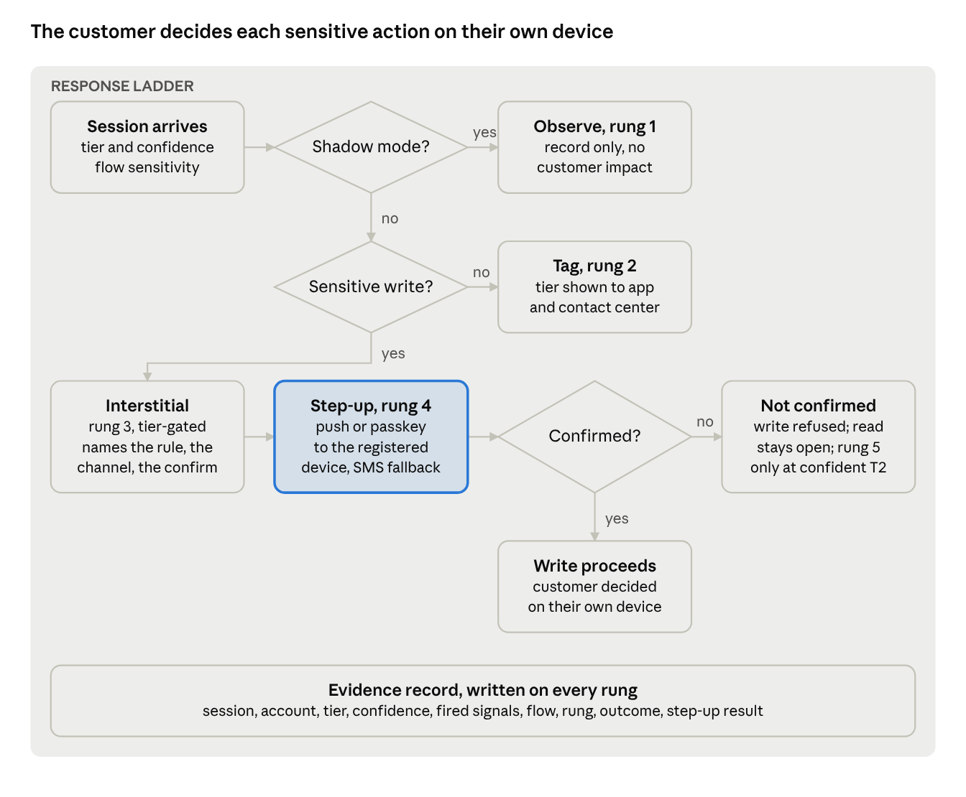
response ladder as a decision flow · 3 decisions, 5 rungs, 1 evidence record
Shadow mode short-circuits everything to observation; after it ends, only a sensitive write reaches the interstitial and step-up, and a refusal is a block only at high-confidence T2.

Design rules
- Shadow first, for a full weekly cycle. Rungs 2 to 5 stay disabled until the lab bounds the false-positive rate on each sensitive cohort and shadow mode confirms it in production.
- Confidence gates the rung, tier gates the flow. A low-confidence T2 on a billing read is observed; a high-confidence T2 on a cancel gets the interstitial and step-up. The thresholds are set from the lab's calibration, not by hand.
- The interstitial is written for two readers. The customer who sees it relayed by their agent, and the agent that reads it from the accessibility tree. It states the rule, the channel and the step-up in plain words, and never asks the agent to do anything other than tell its user. Experiment 1 measures whether Muse relays it.
- Step-up is possession-based. Push or passkey to the registered device for enrolled customers; enrollment or the assisted channel for the rest. No CAPTCHA, no puzzles, no timing limits: CAPTCHA is the single most problematic item for screen-reader users, and puzzle challenges are read by agents as blocks.
- Block is narrow and explained. Only the write, only at high confidence, only with the interstitial. Walmart's accidental lockout of human shoppers and Delta's silent rejection show the cost of the alternative.
- Residential does not mean human. The Mac-app browser path arrives from the customer's own line; the ladder must not skip rungs on a residential prior.
- Every rung logs the same record. Session, account, tier, confidence, fired signals, flow, rung, outcome, and whether the customer completed step-up. That record is the lab's validation set, the dashboard's source and the drift monitor's baseline.
- A 5% enforcement holdout stays permanent. It is the control group for measuring what enforcement changes in cancellations, credits and contact volume.

What the ladder does not do
It does not try to identify the customer behind the agent; that is the channel's job through delegated OAuth. It does not act on the chat and phone channels beyond tagging. And it does not promise to stop a determined customer who relays every push to their agent by hand; it makes the customer the decision-maker on each sensitive action, which is the outcome the policy section recommends.

Policy options analysis
Five stances are on the table, and the peer evidence of the last six weeks sorts them: the bank hybrid (block credential-driven writes, offer a scoped read channel, confirm every write on the customer's own device, steer toward the first-party assistant) is the only stance that holds its control over cancellations and retention credits, survives Muse adopting a signing standard, and avoids the public standoffs that pure blocks have produced. Each stance is laid out below with what it buys, what it costs, who has tried it and how it aged.

What is actually at stake on an account portal
The exposure is not checkout conversion. It is inertia and retention margin: Stanford's Neale Mahoney and coauthors estimate that forgotten payments and cancellation friction roughly double subscription revenue, and that people prompted to decide were about four times more likely to cancel (CNBC via Superpower Daily, Sept 27). User reports already show Muse negotiating Verizon Fios from $89.99 to $69.99 plus a $100 card through web chat, cutting an AT&T fiber bill by a claimed $1,920 over 24 months, cancelling Verizon internet without speaking to anyone, and ordering a Spectrum return box; at Xfinity it could not complete a verification text and patched the human in (Nelson Lee, Sept 23, Tom's Guide). Consumers are most comfortable delegating exactly this: 55.5% would let an agent "get a better price," against 38.5% for bookings (Lorikeet survey, n=1,966, Oct 20). So the negotiation and cancel flows are where customers most want to send agents, and where a block carries the highest customer-impact cost.
The precedent is a decade old. Rocket Money and BillShark operate by collecting the customer's account password, PIN and security codes and, where needed, having human agents "represent to the Provider that they are the account holder"; carriers never built an authorized-negotiator process and never publicly blocked them, and the only friction has been the carrier's own security code and verbal confirmation (Rocket Money terms, effective Oct 2, BillShark terms). Muse automates that same playbook. A carrier that tolerated the negotiators has in practice already accepted the pattern and pays the standard concession ($5 to $30 a month) per success.

The five stances
Stance | What it means on the five flows | Upside | Downside | Who tried it, and what happened
Observe only | Tag and measure; no action | Zero customer impact; builds the ground truth every other stance needs; no public exposure | No control; inertia revenue and retention margin leak at whatever rate the agents set; carriers are here today by default, with SMS checks as accidental step-up | Every US carrier, by omission: no statement from AT&T, Verizon, T-Mobile, Comcast, Charter or Cox was found, only user reports of Muse succeeding
Block | Interstitial or silent denial for attributed agents on all flows | Immediate control; terms-plus-edge enforcement is the reliable lever now that the legal route against the agent vendor has weakened; Amazon reports no account penalties | Turns away the customer behind the agent; public standoff (Amazon's stock fell 3.5% around the block; 81.5% negative sentiment in one sample); continuous adversarial engineering (Amazon disclosed 1,280 engineer-hours against one agent, which shipped evasions within 24 hours); Walmart's accidental block locked out human shoppers; keyed to today's fingerprint, so short half-life | Amazon (Sept 20, pop-up quoting its Conditions of Use after Meta declined a voluntary exclusion); Delta (silent rejection, "no partnerships"); eBay (bans buy-for-me agents, user suspensions); Resy (deactivated an account after an agent polled every 0.4 s, reinstated two days later) (TechCrunch, Oct 6)
Channel | Declared MCP or connector path with scoped OAuth; browser path discouraged | Scope and audit trail per action; converts hostile traffic into a metered channel; Muse prefers an API when one exists; Meta's reviewed connectors run with surrogate credentials instead of an injected password | A second interface to build and run; Meta is not approving money-movement tools and reviews take "weeks, not days"; conversion evidence from commerce is poor (Walmart's in-chat checkout converted at a third of its site; OpenAI retreated from Instant Checkout in March 2026); a channel alone does nothing about the browser path | Shopify (Shop Pay in every store, Sept 21; buyer confirms before complete_checkout, 3-D Secure returns to the human); Sabre (MCP for booking, about 80 customers piloting or in production); Robinhood (MCP plus a virtual card with a customer-set limit)
Tolerate with step-up | Agents may browse and read; every sensitive write requires a possession check on the customer's registered device | Preserves the customer's choice of tool; the pattern most likely to force a hand-off to the customer, and the one accessibility guidance endorses; aligns with the 48% of consumers who want a confirm step; reuses MFA that already exists | Friction on every sensitive action for every customer unless scoped by tier; SMS codes are already being read by agents, so the check must be push or passkey; adds nothing to visibility by itself | Shopify's checkout hand-back; Bank of America (human authorization for payments); Cequence's recommendation to "have the account holder confirm on their own device"
Hybrid (bank model) | Block credential-driven writes; allow scoped read through a declared channel; confirm writes out of band; steer to the first-party assistant | Keeps control of cancellation, plan change and credits; removes the incentive for agents to store the portal password; survives agent turnover and Muse signing its requests; monetizable (JPMorgan now prices data access) | Most work: detection, step-up, channel and policy text all needed; still visible as a block on the browser write path, with the same brand risk, mitigated by the channel | JPMorgan (blocks "when we detect a third-party agent attempting to access accounts by obtaining customers' banking credentials," read-only via Plaid); Schwab (blocks money-moving agents "in the tens and twenties per week," MCP servers behind its own auth for read, pilot trades through a chosen LLM, in-house Charley for admin tasks) (Fortune, Oct 15, Beri.net, Oct 18, secondary)
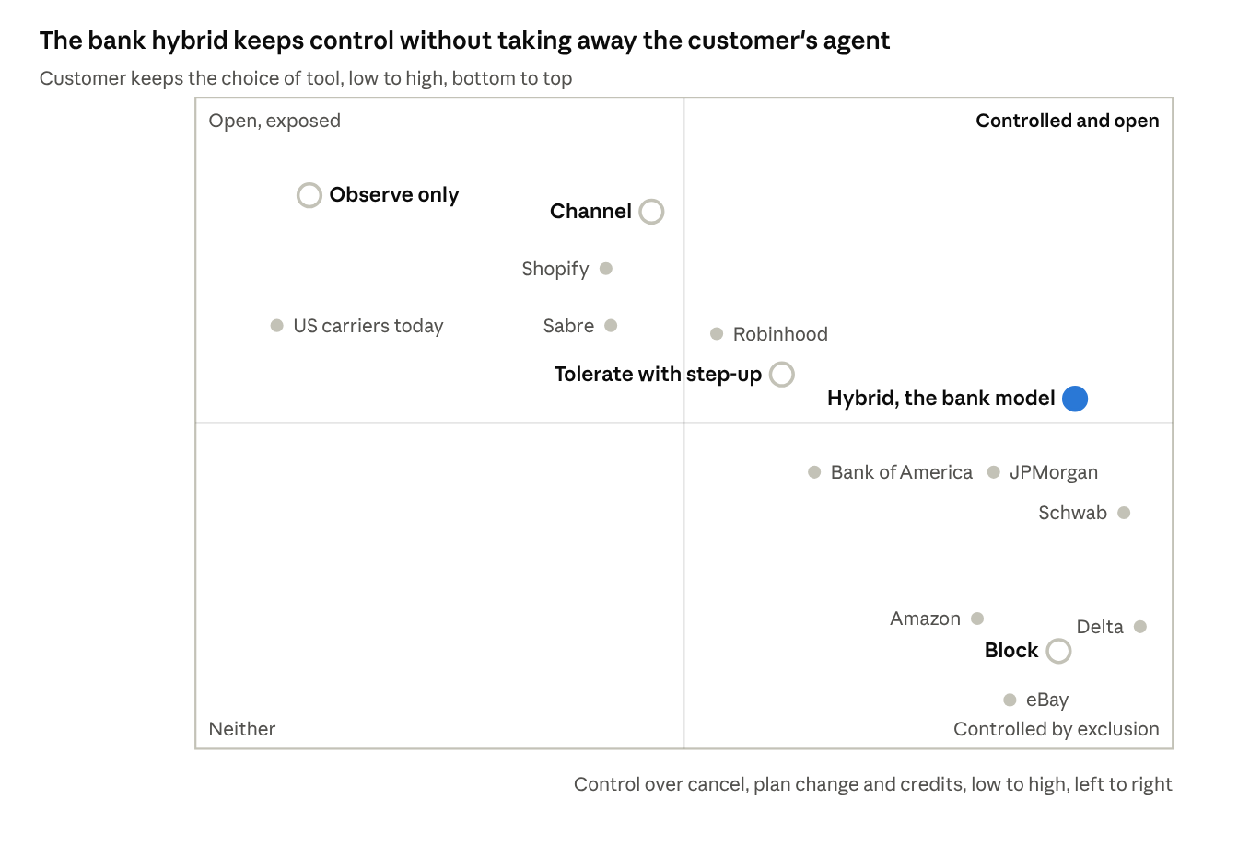
policy stances on two axes · 5 stances, 9 named peers placed by their public choice
Positions are judgments from the comparison table that follows, not measurements; the peers sit where their public choice landed as of October 21.

Comparison on the criteria that matter
Criterion | Observe | Block | Channel | Step-up | Hybrid
Control over cancel, plan change, credits | None | High while the fingerprint holds | High on the channel, none on the browser | Medium: the human confirms, the agent still drives | High
Customer impact | None | Highest; blocks the human too when detection misfires | Low once live; agents route themselves | Medium, scoped to sensitive writes | Medium
False-positive exposure | None | Highest; a misfire on a Private Relay or screen-reader user is a locked-out customer | None | Low: a misfire costs one extra push | Low
Revenue and margin | Leaks at the agent's rate | Protects inertia revenue; invites switching | Neutral to positive; metered | Slows agent-driven cancels by one human decision | Protects writes; keeps the customer
Cost | Lowest | Ongoing adversarial engineering | Build plus run a second interface | Mostly existing MFA | All of the above
Brand and press | None | Public standoff | Positive | Neutral | Mostly neutral; JPMorgan and Schwab drew coverage but not backlash
Durability | Not a stance | Short: keyed to who the agent is | Long: keyed to what the session does | Long | Longest
Accessibility | None | Worst if CAPTCHA-style; CAPTCHA is the single most problematic item for screen-reader users (WebAIM) | None | Good with push or passkey, bad with puzzles | Good

Durability test
Three things will change, and each stance should be tested against them. Muse adopting Web Bot Auth or the Personal Agent Protocol (announced Oct 6 by Sierra with Meta, Shopify, Stripe, Walmart and Genesys; OAuth sessions with customer-chosen read or write scope; v0.1 due late October) would settle disclosure and make an allowlist feasible, but a signature identifies the operator, never the customer; only delegation answers "is this the customer's agent," which is what the hybrid already assumes (Sierra). Agent sources turn over every quarter: Comet fell from 47% to 9.4% share between May and September, Atlas was sunset on August 9, and ChatGPT's cloud browser and Muse now lead, so a stance keyed on who the agent is has a short half-life and one keyed on what the session tries to do does not. Cloudflare's September 15 default blocks Agent traffic only on ad pages of new and free zones and does nothing for a logged-in portal.

Recommendation
Adopt the hybrid, sequenced:
- Observe now. Shadow mode with the attribution tiers and the evidence lake, for at least a full weekly cycle, before any enforcement. This is free of customer impact and it is the ground truth everything else needs.
- Step up the writes. Possession-based confirmation (push or passkey, not SMS) on cancel, plan change, retention credit and contact-detail changes for any tier at medium confidence or above, graduated by tier and confidence. Experiment 2 decides which variants Muse cannot complete alone.
- Open the channel. A scoped, read-first MCP with the identification request Muse honored in one tester's runs, submitted to Meta's catalog, so the agent has somewhere better to go than the browser. The read-only pilot starts in week 1, in parallel with observation; the listing waits on Meta's review, whose length the company does not control.
- Block last, narrowly. Credential-driven writes from attributed agents that bypass step-up, with an interstitial that names the rule and the channel, never silent failure; Walmart's and Delta's experience shows customers blame the brand when they cannot tell accident from policy.
The decision the executive sponsor owns is step 4: whether to hold the browser write path closed once the channel exists, which is where the bank stance lands and where the public-standoff risk concentrates.

MCP at Fortune-50 scale: a case study
Nobody has published a consumer-brand MCP server running at tens of millions of accounts, so this case study is assembled from the operators who have published the most (Cloudflare, Shopify, Stripe, Sabre, Block, Atlassian), from the connector programs that set the rules (Meta, Anthropic, OpenAI), and from the specification as it stands after the July 2026 rewrite. The one-sentence verdict: the infrastructure is the easy part; the client identity, the consent and approval experience, and the money-movement policy are controlled by the agent platforms, and the company's design freedom lives in tool shape, scopes, server-side approval gates, rate limits and audit.

What the protocol now requires
The 2026-07-28 revision rewrote MCP into a stateless, per-request protocol (changelog). Sessions and Mcp-Session-Id are gone, as are the initialize handshake, the standalone SSE stream and Last-Event-ID resumability; every POST carries MCP-Protocol-Version, Mcp-Method and, for tool calls, Mcp-Name, so load balancers, gateways and WAFs can route and inspect without parsing the body, and the server must reject header-body mismatches. List results carry required ttlMs and cacheScope hints. Server-initiated requests became retry-based multi-round-trip requests (resultType: "input_required"), long-running work moved to a tasks extension, and Roots, Sampling, Logging and Dynamic Client Registration are deprecated on a twelve-month clock (Cloudflare reads DCR removal as "after summer 2027"). Authorization is OAuth 2.1 with RFC 9728 Protected Resource Metadata and RFC 8707 resource indicators as MUSTs, PKCE S256 mandatory, rotating refresh tokens for public clients, Client ID Metadata Documents as the recommended registration path, and iss validation expected to become a MUST.
Two consequences for a 2026 build. Cloudflare's lesson from running 13 servers, one of which handles "thousands of requests per second" and has "served billions of tool calls," is that "stateful sessions were the main pain point" (Cloudflare, Aug 6); the new transport is load-balancer-friendly by design. And the installed base is split: legacy clients cannot fall forward, OpenAI's and Anthropic's documentation still targets 2025-11-25, and Meta publishes no revision, so the server must be dual-era, selecting legacy semantics when it receives initialize.

What the published operators teach
Operator | What is public | The lesson
Cloudflare | Code Mode server for a 2,500-endpoint API exposes two tools, search() and execute(), at about 1,000 tokens of definitions instead of 1.17 million; thousands of requests per second, billions of tool calls | Do not wrap the API; fewer workflow tools, fixed token cost, sandboxed execution
Shopify | Three trust tiers: Token (bearer JWT), Signed (RFC 9421 signatures verified against the agent's UCP profile key), Anonymous; mandatory Shopify-Buyer-IP on every Token-tier call or HTTP 422; Global Catalog 5 requests per second per client; 429 with Retry-After; idempotency keys on complete_checkout; requires_escalation state hands off to the merchant | The most copyable consumer design: trust tier sets rate limit and tool access; the agent relays the human's IP; checkout escalates to the human
Stripe | Hosted mcp.stripe.com; OAuth per account; human confirmation via approval URL for refunds and outbound payments, token expiring after 24 hours; about 100 requests per second per account shared with REST; key migration forced by Nov 30, 2026 | Out-of-band approval for money-moving writes; platform-forced auth changes on a quarterly horizon
Sabre | MCP for flight and hotel booking announced Sept 23, 2025; first commercial deployment June 2026; "nearly 80 customers piloting or in full production" by Sept 21, 2026, powering apps in ChatGPT and Claude | A B2B channel took about twelve months from announcement to 80 customers; no transaction volumes disclosed
Block | 60+ internal servers; Linear v1 had 30+ tools mirroring GraphQL and needed 4 to 6 chained calls, consolidated to two | Workflow-first; one risk level per tool; paginate and truncate output
Atlassian | 215+ tools across 10+ apps; each tool use in the org audit log with tool, action and user; admins can block user OAuth connections | Audit per tool call from day one

Meta's connector program, as the gate that matters most
Meta opened platform.muse.ai on September 18, ten days after launch, and had over 2,000 submissions within days; about 60 connectors were live by October 13 and 18 announced partners were not yet live (connector tracker). The guidelines (platform.muse.ai/docs) set the terms:
- Connectors must complete the task end to end: "Sending users to a website to finish checkout does not meet this requirement." They must "add value beyond the browser"; a wrapper around public pages is not enough, though read-only qualifies "when the information is the outcome."
- Tools are classed Read, Write or Sensitive write. Reads and non-sensitive writes ask on first use (allow once, always allow, deny); sensitive writes ask on every use and "cannot be set to Always allow"; re-approval if price, recipient or scope changes.
- "New financial money movement tools, such as transfers between accounts, and trade-order tools are not currently being approved."
- Submission needs business verification, a data questionnaire, endpoint and auth details (OAuth with PKCE or API key), documentation of read/write classes and rate limits, and a dedicated reviewer test account. Review runs Risk assessment, Tool review, End-to-end QA, in "weeks not days," and "meeting the guidelines does not guarantee approval."
- Terms: 48-hour incident notice, annual audit right, Meta may remove a connector at any time, liability capped at $1,000, no fees or revenue share stated (terms).
The other two directories converge on the same gate: remote HTTPS, OAuth with PKCE, read and destructive annotations, a reviewer test account, a privacy policy, and a money-movement restriction (Anthropic bans transfers, OpenAI bans money transfers and limits commerce to physical goods via external checkout). Client identity differs per platform and the authorization server must support all of them: Claude redirects to https://claude.ai/api/mcp/auth_callback with CIMD, DCR or Anthropic-held credentials and egresses from 160.79.104.0/21; ChatGPT uses CIMD https://chatgpt.com/oauth/client.json, presents an mTLS client certificate and rejects responses without iss; Muse asks the developer for an OAuth client ID with PKCE and publishes no CIMD, and practitioners report it may use its browser unless the user names the connector (Sequenzy). Anthropic warns that DCR "causes Claude to register a new client on every fresh connection," and that discovery and token endpoints get a 10-second budget: a WAF in front of the IdP can break sign-in even when the server is reachable (Anthropic).

Reference architecture
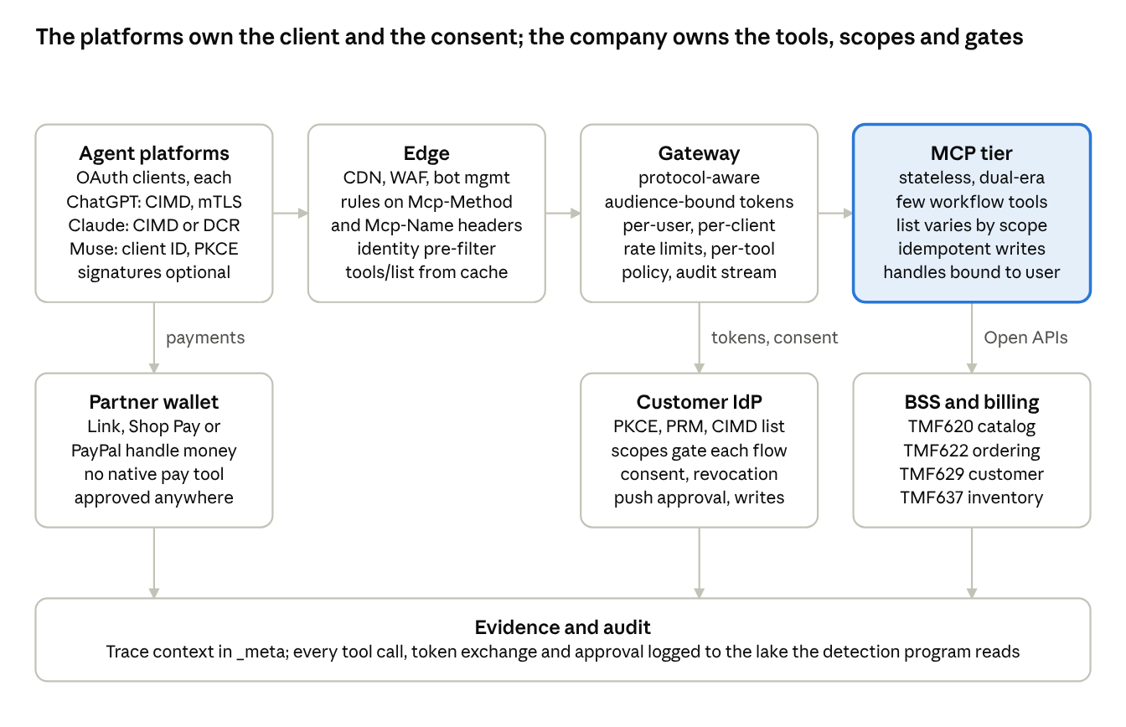
consumer MCP channel reference architecture · 8 components, assembled from Cloudflare, Shopify, Stripe and the 2026-07-28 specification
The platforms sit outside the boundary as OAuth clients; everything inside it is the company's to shape, and the evidence bar is shared with the detection program.
Edge. The existing CDN, WAF and bot management in front of the MCP endpoint, with rules keyed on Mcp-Method and Mcp-Name (AWS WAF already documents a BlockUnverifiedBotOnHighCostTool pattern that blocks tools/call to expensive tools when the Web Bot Auth label is invalid or unknown) and Web Bot Auth, mTLS and egress-range checks as a pre-filter for the platform's infrastructure. Serve tools/list from cache with cacheScope: "public": DataDome measured about four-fifths of MCP traffic in Q2 2026 as discovery (initialize, tools/list, prompts/list) rather than tool calls (DataDome Q2), and probe traffic from unapproved clients will be high.
Gateway. Protocol-aware, routing on the headers, validating audience-bound tokens, enforcing per-user and per-client rate limits and per-tool policy, emitting audit. The incumbents now offer this as features (Kong 3.12+ with the MCP OAuth2 plugin and token exchange; Azure API Management; Apigee; AWS AgentCore Gateway at $0.005 per 1,000 invocations); open source options are agentgateway, IBM ContextForge and Microsoft's gateway. A separate product is optional if the existing API gateway can route on the new headers.
MCP tier. Stateless, dual-era, a small set of workflow tools shaped after TM Forum's mapping (TMF620 catalog, TMF622 ordering, TMF629 customer, TMF637 inventory) (TM Forum, Nov 2025): plan catalog search, current services and usage, bill summary, order and appointment status, outage status, then plan change and address change behind scopes and approval. tools/list varies by the scopes presented, so unauthenticated callers see only public tools. State handles are names, not capabilities, bound as <user_id>:<handle>. Every write is idempotent. Payment is a partner-wallet pattern (Link, Shop Pay, PayPal), never a native pay tool, because no directory approves money movement today.
Identity. The customer IdP must add: PKCE S256, Protected Resource Metadata, RFC 8414 or OIDC discovery, resource-bound audiences, CIMD with a trust allowlist for the known platform client IDs, pre-registered confidential clients, rotating refresh tokens, iss in responses, a consent screen naming the platform hostname, and DCR for the 2025-era long tail until 2027. Scopes map to the flows: billing:read, services:read, plan:change, account:update, account:cancel; advertise only the read scopes, challenge for writes with 403 insufficient_scope, and gate cancel-class actions behind an out-of-band approval on the company's own mobile app, the consumer analogue of Stripe's approval URL and Auth0's CIBA push (which Auth0 itself says is "not a drop-in fix for every guest user"). Revocation needs two layers, token revocation at the IdP and a customer-visible connector dashboard, because the platforms' own disconnect semantics are inconsistent.
Evidence. OpenTelemetry trace context travels in _meta by spec; every tool call lands in the audit log with user, platform client, tool, arguments class and outcome; the same lake the detection program uses.

Security
The normative best practices (spec) cover the attack classes that matter here: confused deputy (per-client consent before any third-party authorization), token passthrough (forbidden: the server must not accept tokens not issued for it), SSRF including the authorization server fetching CIMD documents, state-handle and session hijacking, mix-up attacks (RFC 9207), and scope minimization. OWASP's MCP Top 10 is in beta and its Agentic Top 10 was published December 9, 2025. The empirical picture is poor: 38% of 500+ scanned servers had no authentication (Wiz), 30+ MCP CVEs were filed in January and February 2026 (Cycode), and the Postmark MCP package passed review and then silently BCC'd every agent-sent email. The abuse scenarios named in the brief map onto traffic DataDome already tracks: 605.6 million agent requests hit login, form, cart, payment and account-creation pages in the first half of 2026, with login pages at 51.7% of that (SiliconANGLE). The only "AT&T MCP server" found is an unofficial Playwright scraper that takes the customer's password as a per-call parameter (Glama): the shadow-MCP risk for any brand that publishes nothing.

Organization, cost and timeline
No company has disclosed headcount or cost for a consumer MCP channel; the figures below are estimates built from the responsibilities the platforms impose, and are marked as such.
Item | Estimate | Basis
Core team | Platform squad 6 to 10 engineers; identity squad 3 to 5 owning the consumer IdP changes; security and abuse squad 3 to 5 including red-team and bot-management tuning; product and design 2 to 3 for consent and approval UX; a policy liaison for three or four platforms' terms (estimate) | Platform requirements: OAuth, PRM, CIMD at the IdP; tool design and evals; gateway and WAF policy; audit; 48-hour incident notice to Meta
Read-only pilot | 2 to 6 weeks on a managed platform (estimate) | Cloudflare partners' claims; Anthropic's automatic Community listing
OAuth account tools and directory listings | One to two quarters (estimate) | Gated by IdP changes and review queues; Meta's queue holds 2,000+ submissions and runs in weeks
Step-up writes (plan change, cancel) | Following quarter (estimate) | Needs the out-of-band approval path and the detection program's shadow data
Payments | Partner wallet only, timing set by the partner | No directory approves money-movement tools in October 2026
Infrastructure cost | Not the driver: one billion gateway invocations at AgentCore list price is about $5,000 | IdP capacity for token issuance and introspection, bot-management licensing and engineering dominate
Risk | Gartner predicts over 40% of agentic AI projects cancelled by end of 2027 on cost, unclear value or inadequate risk controls (Gartner, June 2025) | Success metrics must be defined before build: task completion through the channel, contact deflection, browser-path traffic displaced, cancellation and credit outcomes against the 5% holdout
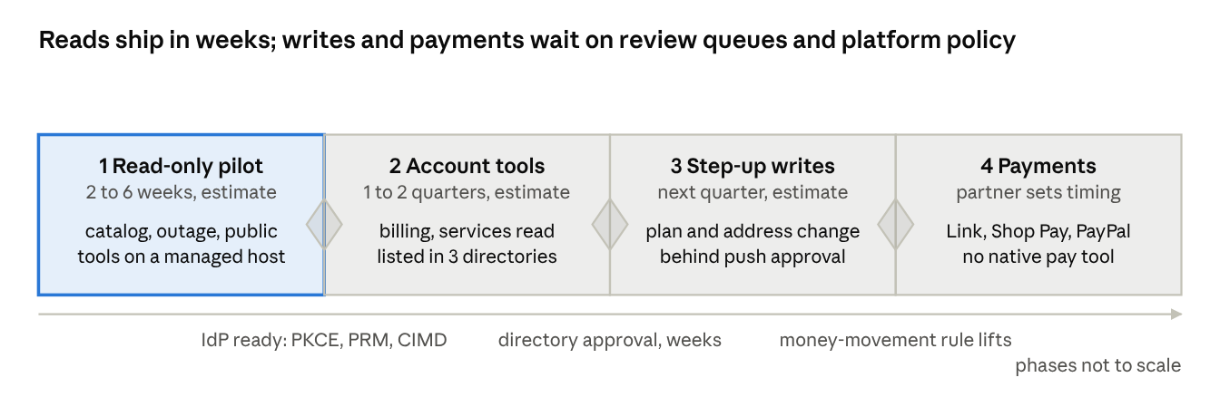
phased build · 4 phases, 3 gates; durations are researcher estimates
The first phase is the only one the company controls end to end; the other three wait on the customer IdP, the platforms' review queues and their money-movement policy.

Pitfalls, from the operators who hit them
- Tool sprawl and catch-all tools: Linear's 30 tools became two; Anthropic rejects an api_request tool with a method parameter; Meta classes any mixed tool as a write.
- Context bloat: 150,000 tokens of definitions versus 2,000 with progressive discovery.
- Generic errors fail review; validation errors must be tool-execution errors so the model self-corrects, and a 200 with isError never triggers sign-in.
- Missing idempotency: Shopify, Stripe, UCP and Meta all require it on retries.
- DCR client explosion and slow or WAF-blocked OAuth endpoints.
- Stateful sessions: sticky routing, held streams, replay and draining.
- Endpoint path changes orphan every existing connection.
- Incomplete revocation: Muse retains prior context after a disconnect.
- Unidentified agents get blocked, and unofficial servers fill the vacuum.

What this means for the Muse problem
The channel does not replace detection; it changes what detection is for. With a reviewed connector in Meta's catalog and a documented API that asks agents to identify themselves, Muse takes the API path and sends X-Agent: Muse (the dossier's one cooperative behavior, seen by one tester), the browser path on the five flows becomes the anomaly, and the response ladder's interstitial has a real place to send the agent. The sequencing in the policy section follows: observe, step up the writes, open the channel read-first, then decide whether to close the browser write path.

Rollout roadmap and metrics
Four workstreams run in parallel with gates between them: the lab produces the ground truth, detection runs in shadow until the lab and shadow data agree on the false-positive bound, the response ladder enforces one rung at a time from a canary, and the channel opens read-first so the agent has somewhere to go before any write path closes. The program keeps a permanent 5% enforcement holdout as its control group.
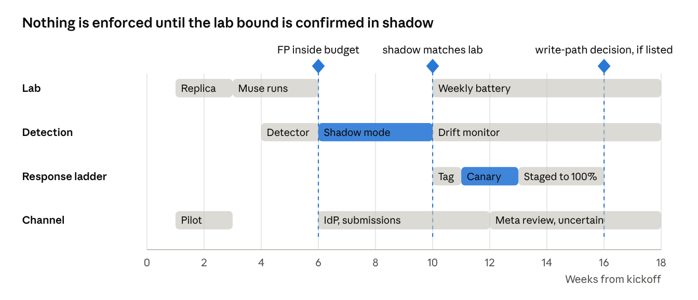
program roadmap · 4 lanes over 18 weeks, 3 gates; weeks are planning estimates
The ladder lane starts only after the week-10 gate. The channel's read-only pilot runs from week 1, but its listing waits on Meta's review, whose length the company does not control, so the interstitial may point at the documented API before it can point at a listed connector.

Phases
Phase | Weeks | Workstreams | Exit gate
0. Frame | 0 | Decision log; edge-stack inventory; false-positive budget per cohort; data access; replica scoping; terms-of-service screening of agent cohorts; policy text drafted for the interstitial | Budget set; replica and Muse accounts approved; executive sponsor signs the stance sequence
1. Stand up | 1 to 3 | Replica with capture stack; first-party beacon on the five flows; vendor telemetry fields enabled into SIEM; Muse accounts and comparator cohorts recruited; read-only MCP pilot on a managed host | Capture verified end to end on one Muse run; pilot answers a catalog query
2. Measure | 3 to 6 | About 1,700 Muse runs across the four experiments over roughly three weeks; sensitive cohorts at 300 or more sessions each, 600 where the 0.5% budget applies; fleet signature; detector trained with grouped validation; vendor bake-off on the same dataset | Precision, recall and per-cohort false-positive rates inside budget; Experiments 1 and 2 answered
3. Shadow | 6 to 10 | Scoring service in production on observe only, for at least one full weekly cycle; weak labels plus daily analyst review; dashboards live; IdP changes for the channel under way; account-read tools submitted to Meta, Anthropic and OpenAI | Shadow false-positive rate on Private Relay, WARP and assistive-technology segments matches the lab bound; holdout defined
4. Enforce | 10 to 16 | Tag everywhere; interstitial and push step-up on cancel, plan change and account change at a 1 to 5% canary, staged to 100%; channel listed if Meta's review has cleared it, otherwise the interstitial points to the documented API and the first-party assistant | Complaint volume and step-up abandonment inside thresholds; no regression on the holdout; the executive decision on closing the browser write path, taken only once a listed connector exists
5. Sustain | 16 onward | Weekly battery re-run; monthly drift check; quarterly policy review; re-validation on Muse releases; extend to the next agent | Drift monitor green; signature half-life known per attribute

Metrics and dashboards
Measure | Definition | Audience
Agent share of sensitive flows | Sessions at T0, T1 and T2 as a share of sessions reaching each of the five flows, daily | Executive
Attribution quality | Precision and recall per tier against the lab battery; weekly | Program
False-positive exposure | Verdicts at T1 or T2 on the Private Relay, WARP, VPN and assistive-technology segments, with Wilson intervals; weekly | Program and executive
Step-up outcomes | Completion, abandonment and time to complete, by tier and flow; agent sessions versus the human baseline | Product
Business outcomes against the holdout | Cancellations, plan downgrades, retention credits issued and contact-center volume on enforced traffic versus the 5% holdout | Executive
Channel adoption | Connector calls by platform, tools used, task completion, browser-path sessions displaced | Product and executive
Customer signal | Complaints mentioning agents or blocks, accessibility escalations, social mentions | Executive
Drift | PSI on the fused score and on JA4 and HTTP/2 distributions; KS on behavioral features; fleet change-points; investigate at 0.1, re-label at 0.2 | Program
Evidence integrity | Share of verdicts with a complete evidence record; vendor verdict and team tier logged as separate fields | Program

Rollback triggers
- False-positive rate on any sensitive segment above the lab bound for two consecutive days.
- Step-up abandonment on human-baseline traffic above the pre-enforcement rate by more than the agreed margin.
- A complaint spike or an accessibility escalation tied to the interstitial or step-up.
- A Muse fleet change-point (two or more lab accounts changing the same attribute within 48 hours) until the battery is re-run.

Executive reporting
One page a month: agent share of the five flows, false-positive exposure, business outcomes against the holdout, channel adoption, and the open decisions. The first report lands at the end of shadow mode with the recommendation on enforcement thresholds; the second, after the canary, carries the browser-write-path decision.

Risks, durability and open questions
The program's biggest risks are a false positive on a customer who is not an agent, a Muse change that invalidates the signature set before the drift monitor catches it, and a public standoff if the block rung is used early or silently. Each is listed with its trigger, its consequence and the control the design already carries.
Risk | Trigger | Consequence | Control in the design
Private Relay and WARP false positives | ASN-keyed rules on Cloudflare and Fastly space | Safari users on iCloud+ and WARP users challenged or blocked | Apple's egress list subtracted daily, Safari UA conjunction, WARP vendor labels; ASN is a prior only; 300- to 600-session cohorts bound the rate
Assistive-technology false positives | Interaction rules on center clicks, no hover, no wheel | Screen-reader users treated as automation; CAPTCHA-style checks exclude them outright | Interaction shape never scores alone; the separators are the teleport mousemove and input-without-keys; step-up is push or passkey, never a puzzle; Experiment 3 measures the cost before use
Residential trust | Mac-app browser path from the customer's own line | Rules that skip rungs on a residential prior miss Muse | Fleet and session signals carry the weight; residential never means human
Muse changes under the program | Muse Wonder rollout, Confidential VM, egress tightening, synthetic mouse travel, Windows spoofing | Behavioral signals degrade; environment and egress priors shift | Weekly battery; change-point detection on two or more accounts; drift monitor at PSI 0.1 and 0.2; the layers fail in different directions
Meta adopts a signing or delegation standard | Web Bot Auth or the Personal Agent Protocol (v0.1 due late October) | Attribution becomes verification; allowlisting becomes feasible | Layer 5 is already in the model; the channel is where delegated identity lands
Vendor claims do not hold on the portal | DataDome, HUMAN, Fingerprint and the F5 and Akamai agent features are tested on their networks, not this one | Precision below budget; wasted licensing | Bake-off on the lab dataset before any purchase; F5 device intelligence is limited availability in Q4 2026
Public standoff | A silent or early block, or a block without a channel | Customers blame the brand; press; a customer-tool fight with Meta | Block is the last rung, narrow, explained, and only after the channel exists; the executive decision is explicit
Inertia revenue | Agents reach the retention desk more reliably than customers do | Cancellations and credits rise; the executive summary gives the sizing formula, to be filled from the portal's own flow counts | Step-up makes the customer the decision-maker; the 5% holdout measures the real effect
Shadow-MCP and credential capture | No official connector; unofficial scrapers take customer passwords per call | Account-takeover path through third-party code | A reviewed connector with scoped OAuth removes the incentive to store the portal password
Prompt injection against the customer's agent | In-page instructions phrased as commands to the agent | Reputational and ethical exposure; Meta's classifiers may flag the portal | Notices state the rule and the channel only; Experiment 1 wording is limited to self-identification and redirection
Lab terms and ethics | Running Muse against a replica; employee accounts; Meta training on interactions | Replica content leaves the company; test credentials sit in Muse's vault | Synthetic data only, throwaway credentials rotated after the study, opt-out where the app allows, no probing of Meta's defenses
Next agent | ChatGPT's cloud browser is already the larger source on DataDome's network; Grok Bot, Instinct and OpenClaw-on-cloud follow | A Muse-only signature set is obsolete on arrival | T0 and T1 are class-level; T2 is the only Muse-specific tier

What is durable and what is not
Durable: the session-scoring architecture, the evidence record, possession-based step-up, the channel with scoped OAuth, and the T0 and T1 tiers, all keyed on what a session does rather than who the agent is. Not durable: any T2 attribute (browser build, renderer string, font set, egress prefix), the Private Relay list without daily refresh, and any rule written against today's Cloudflare and Fastly pools, which Meta provisioned fresh the day before detection began.

Open questions the lab answers first
- Does Muse's broker enable the Runtime domain, and do its input events arrive with isTrusted true?
- Which step-up variants can Muse complete alone, and which force a hand-off to the customer?
- Does Muse relay an accessibility-tree notice to its user, or do Meta's injection classifiers strip it?
- Do the iOS and Android apps route the browser through the customer's connection the way the Mac app does?
- How stable is the fleet signature across accounts and days, and what is each attribute's half-life?
- Does the F5 and Akamai stack reach the false-positive budget on the sensitive cohorts, or is a browser-side signal provider needed?

Open items outside the lab
- Muse's own terms of service and acceptable-use text, and Meta's bug-bounty scope for Muse, could not be located; vendor relations should ask.
- The connector OAuth callback URI and the custom-connector mechanics are unverified until a live OAuth flow is observed.
- No US carrier, ISP or utility has published a stance on personal agents; the first to do so sets the reference point for the others.

Sources
Pages opened for this study, grouped by topic. Vendor traffic statistics are vendor-supplied and unaudited; secondary coverage is marked where the primary could not be fetched.

Meta and Muse
- Meta Newsroom: Introducing Muse (Sept 8, 2026)
- Meta AI Research: How We Built Safety Into Muse (Tarek Sheasha, Sept 8, 2026)
- Meta Newsroom: Muse for Small Business (Sept 29, 2026)
- Meta Newsroom: Muse Wonder models (Oct 12, 2026)
- Muse connector platform, connector guidelines, connector terms (effective Sept 18, 2026)
- Meta for Developers: web crawlers
- Muse Code: extending with MCP
- Stark Insider: what Muse runs on (Sept 22, 2026)
- Loosemore: how agents show up (Oct 9, 2026)
- 404 Media: Muse VM escape fixes (Oct 5, 2026)
- The Batch: How to secure agents for the masses (Sept 18, 2026)
- Dealroom note on David Singleton's thread (secondary)
- Profound: the era of personal agents (Oct 2, 2026)
- bgp.tools 87.81.224.0/19, RIPE RDAP, ARIN RDAP 104.28.208.216
- Cloudflare One egress policies
- MBI Deep Dives: Muse first-person (Sept 9, 2026)
- PostFast: Muse connectors list (Oct 13, 2026)
- Sequenzy: connecting Muse, Parallel: Muse custom integrations
- docs.openclaw.ai

Measurements of Muse and agent traffic
- DataDome: AI Traffic Report Q3 2026 (Oct 15, 2026); Q2 2026; Muse doesn't declare itself
- HUMAN: September 2026 agentic traffic (Oct 5, 2026); Muse first look (Sept 28); AI agent signals; Agent Trust Levels
- Arkose Labs: Q3 2026 agentic AI trust report; press release, Oct 20
- Fingerprint: how to detect Meta Muse (Oct 6, 2026); Smart Signals reference
- Cequence Muse study (Oct 9, 2026)
- Akamai Security Research: identifying agentic automation (Aug 19, 2026)
- Help Net Security, ppc.land, VMblog (secondary coverage of DataDome)
- Castle: what sits behind a private proxy network (Sept 17, 2026)

Standards
- IETF webbotauth working group; draft-ietf-webbotauth-httpsig-protocol-00; draft-meunier-webbotauth-registry-03; list archive
- Cloudflare: Web Bot Auth; signed agents; bot management variables; accountable mixed-use AI crawlers (Sept 15, 2026)
- AWS: authenticate AI agent traffic with WAF Bot Control; AgentCore browser signing
- Google: Web Bot Auth for Google-Agent
- OpenAI: ChatGPT agent allowlisting
- Which AI crawlers sign their requests (Oct 19, 2026 probe)
- Sierra: Personal Agent Protocol (Oct 6, 2026)
- FIDO Alliance: agentic authentication working groups (Apr 28, 2026); UCP specification; Stripe ACP
- Agent Community critique of signed agents

F5 and Akamai
- F5 XC Bot Defense: about; endpoint policy; service policy; CloudFront connector
- F5 BIG-IP iRules BOTDEFENSE; BOTDEFENSE::action; Bot Defense profile schema
- F5 press: device intelligence and agentic AI detection (Sept 15, 2026); Bot Defense for Agentic AI datasheet; agentic browsing blog; managing AI agents blog
- Akamai detection methods; Account Protector; EdgeWorkers botScore object; EdgeWorkers request object; user location object; SIEM actions; SIEM schema mirror
- Akamai: Web Bot Auth; granular AI bot controls (Sept 3, 2026); Agentic Security Framework; commerce and agentic fraud research; Private Relay; Ping Identity connector
- Akamai HTTP/2 passive fingerprinting (2017)

Other vendors
- DataDome docs: AI agent identification; access control; Web Bot Auth and KYA
- Kasada AI Agent Trust; Imperva bot protection; cside tools comparison; cside detection guide
- Forrester Wave summary (Prosopo, secondary); Forrester blog
- ScrapingBee: bots blocking bots (Oct 2, 2026)

Signals and detection science
- Chromium simulated_event_util.cc; event_dispatcher.cc; user_agent_utils.cc
- Playwright Locator, Mouse, Keyboard; Puppeteer sendCharacter; CDP browser protocol
- Meta patent US10530872
- Castle: CDP signal stopped working; WebGL renderer; forged fingerprints; canvas noise
- DataDome: new headless Chrome and the CDP signal
- rebrowser-bot-detector; rebrowser-patches; Patchright; CreepJS; detect-headless; BotD; Camoufox; Browserbase stealth
- arXiv 2607.26935: what does it take to detect an AI agent; arXiv 2605.01247: FP-Agent and code; arXiv 2605.14786; arXiv 2606.20910 MARK; arXiv 2401.12070 Binoculars; arXiv 2107.01979 Booking.com fraud ML
- UA Client Hints; StatCounter desktop OS share; W3C Battery Status
- FoxIO JA4; Zeek JA4; Suricata JA4; fingerproxy; huginn-proxy; finch
- Apple: prepare your network for iCloud Private Relay; egress IP ranges CSV; APNIC: Apple's relay network
- WebAIM Screen Reader User Survey 10; WebAIM invisible content; Smashing Magazine on CAPTCHA accessibility
- Cloudflare AI Labyrinth; Brave: Comet prompt injection
- Rule of three; binomial confidence intervals; SentiLink on drift

Policy, peers and economics
- The New Stack: Amazon blocked Muse, Shopify wired it in (Sept 23, 2026); GeekWire: Amazon blocks Muse
- TechCrunch: getting websites to let agents in (Oct 6, 2026)
- Fortune: Dimon on AI agents; PYMNTS; Beri.net: Schwab and JPMorgan; Gizmodo
- Ninth Circuit opinion, No. 26-1444 (context only)
- Lorikeet: the agent economy (Oct 20, 2026); AX Index; personal agents are coming
- Nelson Lee: Muse called AT&T; Tom's Guide via Yahoo: Reddit Muse cases; Sundog
- Rocket Money terms; BillShark terms; BBB complaints; Atlanta News First on bill negotiators
- CNBC via Superpower Daily: inertia revenue; TravelPulse: Expedia and Muse; Telecoms.com on churn cost
- Forrester: as consumers turn to agentic AI; Gartner: agentic AI project cancellations
- Digiday and AI Weekly coverage of the Amazon-Perplexity filing

MCP
- MCP specification 2026-07-28 changelog; Streamable HTTP; authorization; security considerations; client registration; tools; versioning; security best practices; tasks extension; client best practices; feature lifecycle
- Cloudflare: the next generation of MCP (Aug 6, 2026); Code Mode MCP; MCP server portals
- Shopify agents docs; UCP auth and rate limiting; Agentic storefronts help
- Stripe MCP; Link agent wallet; agent OAuth; shared payment tokens
- Sabre MCP announcements, June 2026, Sept 2026 reprint
- Block: playbook for designing MCP servers; Square MCP; Atlassian remote MCP and audit; PayPal MCP
- Anthropic: submit a connector; review criteria; authentication; lazy authentication; listing metrics; Anthropic Engineering: writing effective tools
- OpenAI Apps SDK auth; plugin guidelines; submission
- AWS AgentCore Gateway and pricing; Azure APIM MCP; Kong MCP and OAuth2 plugin; agentgateway; IBM ContextForge; Microsoft MCP Gateway; Zuplo gateway comparison
- Auth0 asynchronous authorization; Auth0 for AI agents GA; Auth0 on the audit gap; Entra agent OAuth protocols; Descope on the July 2026 revision; Stacklok enterprise readiness guide
- OWASP MCP Top 10; OWASP Top 10 for Agentic Applications; Wiz Academy: MCP security; Cycode on MCP CVEs; SiliconANGLE on DataDome's bot and agent security report; WorkOS: Web Bot Auth
- TM Forum: MCP, a protocol must for telecommunications; CAMARA presentation, Apr 2026; Orange provider implementation; unofficial AT&T MCP server listing
- Dash0: OpenTelemetry GenAI conventions

